**FPT ACADEMY INTERNATIONAL**



## FPT – APTECH COMPUTER EDUCATION

**HARVEL ELECTRIC**

|  |  |  |  |
| --- | --- | --- | --- |
| **Center Name** | | FPT – Aptech – HCM2  Address: 590 Cach Mang Thang Tam, District 3, Ho Chi Minh City | |
| **Instructor** |  | Ms. Le Mong Thuy |  |
| **Class** |  | T1.2104.E0 |  |
| **Group** |  | 6 |  |
| **Group members** | | **Name** | **Student ID** |
|  |  | Nguyen Huu Dai | Student1313748 |
|  |  | Chu Tu Minh Thanh | Student1316202 |
|  |  | Nguyen Van Dung | Student1316206 |
| **Duration** | Start date | 14th July 2021 |  |
| End date | 14th August 2021 |  |

**This is to certify that**

**Mr.:**

Nguyen Huu Dai

Chu Tu Minh Thanh

Nguyen Van Dung

**has successfully designed & developed**

eProject: Harvel Electric website

**Submitted by:**

Nguyen Huu Dai

**Date of issue:**

**Authorized Signature:**

**TABLE OF CONTENTS**

****FPT – APTECH COMPUTER EDUCATION 1****

****TABLE OF CONTENTS**** ****2****

****ACKNOWLEGMENT**** ****3****

****SYNOSIS**** ****3****

****PROBLEM DEFINITION**** ****3****

****CUSTOMER'S REQUIREMENTS SPECIFICATIONS (CRS) 4****

****Business/Project Objective**** ****4****

****Hardware/ Software Requirements**** ****5****

****SCOPE OF THE WORK (IN BRIEF) 6****

****Architecture and design of the system 7****

****Diagram of the website 8****

****TASK SHEET REVIEW 1 9****

****SITE MAP 10****

****MOCK OF THE WEBSITE 11****

***1. Homepage 1******1***

***2. Product 1******2***

***3. Blog 1******3***

***4. About Us 1******4***

***5. Contact US 1******5***

***6. Service 1******6***

***7. Sign In/ Sign Up 1******7***

****TASK SHEET REVIEW 2 18****

WEBSITE DESCRIPTION ****1********9****

RESPONSIVE****28****

****JAVASCRIPT DESCRIPTION 30****

****TASK SHEET REVIEW 3**** ****47****

# ACKNOWLEGMENT

On behalf of team members. I would like to thank everyone who supported my team to successfully complete this eProject report. Especially, our teacher, she has supported us a lot since we started studying at FPT Aptect. With this eProject, she guided us very meticulously, enthusiastically and strictly. With her guidance, we were able to successfully complete this project. Besides, I also want to thank all the team members, each of whom worked hard to complete the eProject in earnest during the month of working together. Finally, our group would like to say thank you to my classmates and family for sharing and creating for the group the best environment to focus on the project, motivating the members to achieve their goals.

# SYNOSIS

# The goal of the eProject is that we need to create a website that meets all the requirements of the client, Harvel Electric. Harvel Electric is an energy company specializing in the supply of various electrical products. They always satisfy customers with professional staff with many years of experience. The main goal of this website is to reach customers who need the best quality electrical products for their home or company. In addition, the products have discounts and promotions for customers, especially the company also supports the direct installation of their products. Customer satisfaction is always the top goal of Harvel Electric.

# PROBLEM DEFINITION

The Web site is to be created based on the following requirements.

1) The Home Page should be created making use of Sections with a suitable logo

2) The site should display a menu which will contain the options for brief introduction about the various products available, location of the shop and any other information if required.

3) The information should be categorized according to different type of products like if a User wants to see only ‘FANS’ then he click on a Link/button/menu etc and he will see different type of FANS. Similarly for ‘GEYSERS’, ‘CFL’ and other products

4) When a user selects any product type, a list of products for that product type will be displayed.

5) A brief summary of features of individual products should be displayed on the Web Page along with the product but detailed Features should be stored in Individual Word documents which can be downloaded or viewed by the User who wishes to see the same.

6) Price List should be available for download.

7) There should be a “Contact Us” page which will have the Address of the Company and the mail address which when clicked will invoke the local mail client from where they can send an email. Address of the Company should be displayed using GeoLocation API (eg. GoogleMaps).

# CUSTOMER'S REQUIREMENTS SPECIFICATIONS (CRS)

**Client: Harvel Electric**

### Business/Project Objective:

The company advertises by distributing the pamphlets, advertising on television and so on. Due to rapid development in internet field, the company decides to launch a website where people will get all the information about the various products available with them easily.

You are supposed to create a website for them with the below mentioned requirement specifications.

The website is to be developed for the Windows Platform using HTML5, JavaScript and Geolocation. The site should work well in all leading browsers including Chrome, IE, Firefox etc.

**Input to the system:**

- Searching products based on FANS, GEYSERS, CFL and other products.

- Register members on website.

- Feedback about the quality of products

**Output from the system:**

- Perform search based on: brand, product type, voltage, capacity...

- Display results for each type of product according to the search content.

- Display product information by price, specifications, brand, image, color, model...

- Display the special information of the product.

- Display products of the same type, same brand, other related products.

- Display a button so that customers can download the product's catalog

- Customers can also download the price list of products on the website

- Site should be able to provide brief introduction/history about the shop under About Us page.

- The location of the shop under Contact-Us page.

- Displays FAQ and allows users to email directly to the company

**Process**:

* + - * Validate data input from users.

**Expected delivery date:** 22-July-2020.

**List of deliverables:**

- Document Word, PDF.

- User Guide.

- Source code.

### Hardware/ Software Requirements:

* **For developer**

**Hardware**

* + Intel Pentium 4 processor or higher
  + 01 Gigabytes of RAM or higher

**Software**

* + Windows 7 OS or higher
  + Adobe Dreamweaver
  + Web browsers such as IE, Chrome or Firefox are supporting HTML5, CSS3 and Javascript.
* **For web users**

**Hardware**

* + Intel Pentium 4 processor or higher
  + 512 Megabytes of RAM or higher

**Software**

* + Windows XP OS or higher
  + Web browsers such as IE, Chrome or Firefox are supporting HTML5, CSS3 and Javascript.

# SCOPE OF THE WORK (IN BRIEF)

After a long and detailed discussion, our group has decided to create a website contain the following webpages:

1. ***Homepage***: There is a search bar to search for products, display promotional information, best-selling products and introduce Harvel Electric.
2. ***Product***: Displays all available products based on the Category category (Fans, Geysers, CFL, Cables & Wires, Switches and Appliances). In the above categories, products can be filtered by name, capacity and price.
3. ***Blog***: Display articles, news, equipment installation instructions...
4. ***About Us***: Display the information of the company, clients’ review and about us.
5. ***Contact Us***: Display the address of the company, Map and allow customers to request any information they want to Harvel Electric.
6. ***Service***: Displays user inquiries, product documents, and product price lists for user downloads, freight services, and equipment installation.
7. ***Sign In/ Sign Up***: Allow users sign up or sign in to the website.

# ARCHITECTURE AND DESIGN OF THE SYSTEM

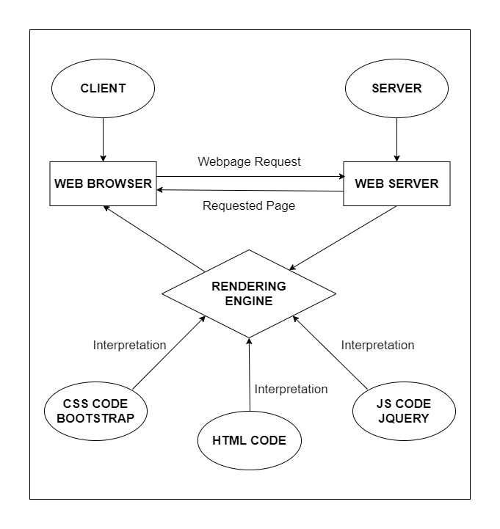

# DIAGRAM OF THE WEBSITE

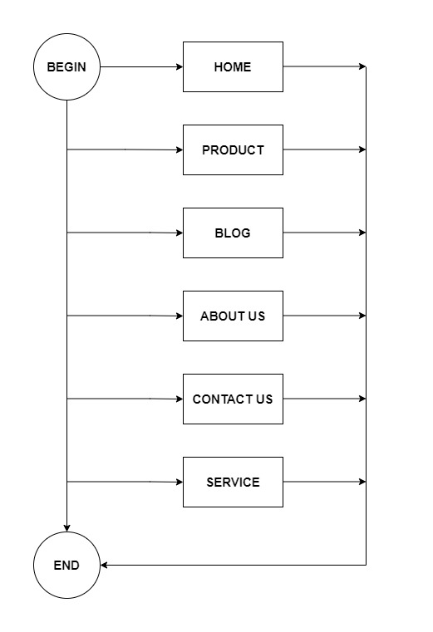



# TASK SHEET REVIEW 1

|  |  |  |  |  |  |  |  |
| --- | --- | --- | --- | --- | --- | --- | --- |
| **Project Ref. No.:**  **eP/Advertisement Portal Management**  **System/01** | | **Project Title:** | **Activity Plan Prepared By:** | **Date of Preparation of Activity Plan:** | | | |
| **Sr.**  **No.** | **Task** | **Actual**  **Start**  **Date** | **Actual Days** | **Team**  **Mate Names** | **Status** |
| 1 | Problem Statement | HARVEL  ELECTRIC | Dai | 14-July-21 | 1 | Dai | Completed |
| 2 | Analysis of Harvel Electric requirements about the website | 14-July-21 | 1 | Dai | Completed |
| 3 | The scope of the work (in brief) | 14-July-21 | 1 | Dung | Completed |
| 4 | Architecture and design of the system | 14-July-21 | 1 | Dung | Completed |
| 5 | Diagram of the website | 14-July-21 | 1 | Thanh | Completed |
| 6 | Task Sheet | 14-July-21 | 1 | Thanh | Completed |

|  |  |
| --- | --- |
| **Date:** | |
| Signature of Instructor:  **Ms. Le Mong Thuy** | Signature of Team Leader:  **Nguyen Huu Dai** |

# SITE MAP

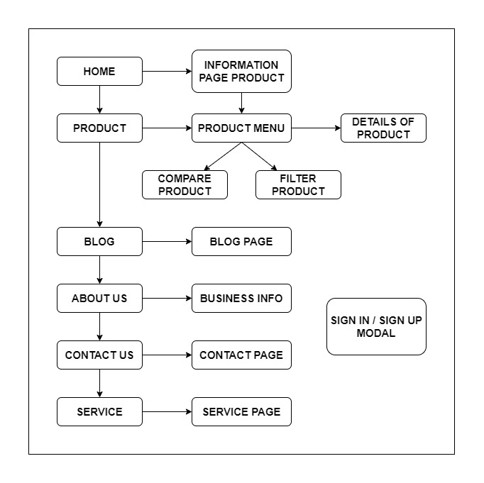

# MOCK OF THE WEB SITE

1. **Homepage**

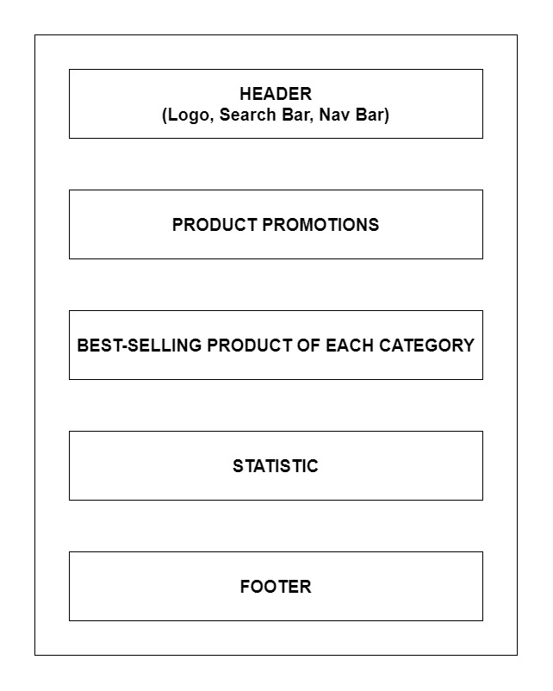

1. **Product**

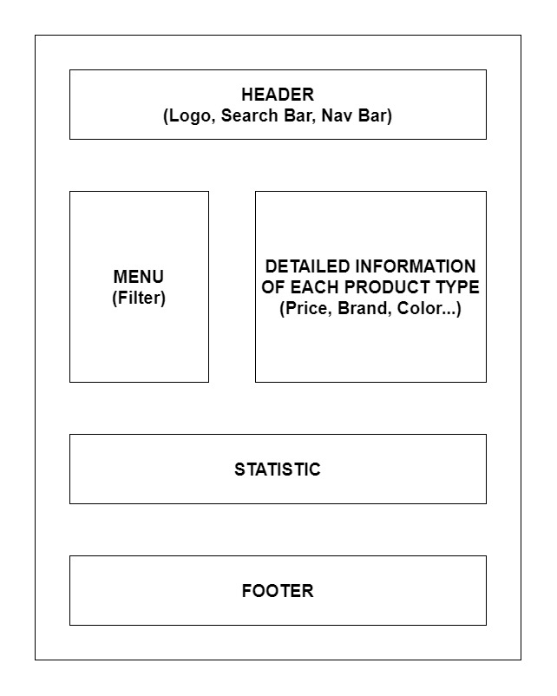

1. **Blog**

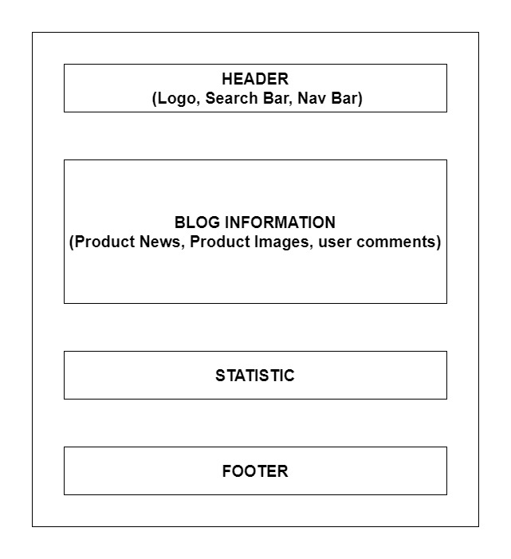

1. **About Us**

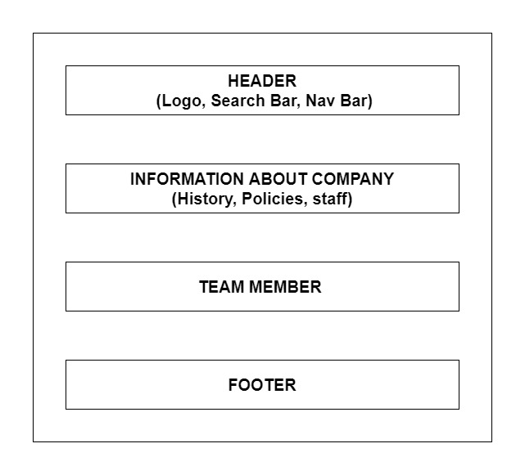

1. **Contact Us**

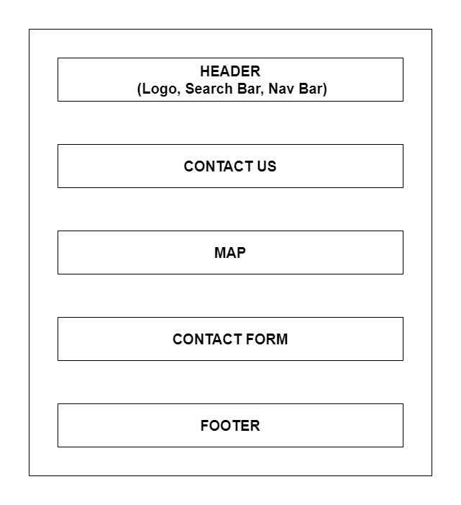

1. **Service**

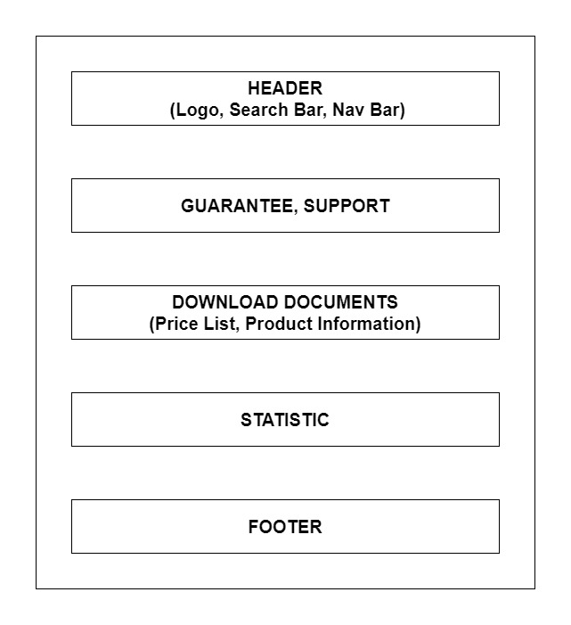

1. **Sign In/ Sign Up**

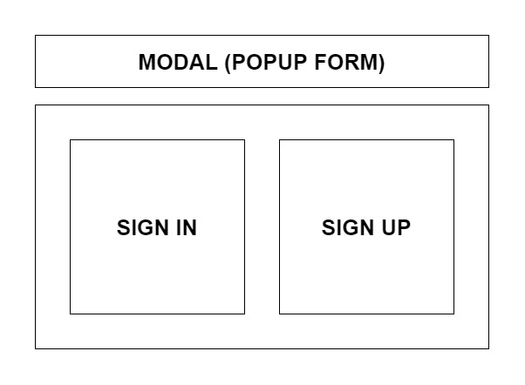

# TASK SHEET REVIEW 2

|  |  |  |  |  |  |  |  |
| --- | --- | --- | --- | --- | --- | --- | --- |
| **Project Ref. No.:**  **eP/Advertisement Portal Management**  **System/01** | | **Project Title:** | **Activity Plan Prepared By:** | **Date of Preparation of Activity Plan:** | | | |
| **Sr.**  **No.** | **Task** | **Actual**  **Start**  **Date** | **Actual Days** | **Team**  **Mate Names** | **Status** |
| 1 | Site Map | HARVEL  ELECTRIC | Dai | 16-July-21 | 1 | Dai | Completed |
| 2 | Mock of the website | 16-July-21 | 2 | Dung | Completed |
| 3 | Task sheet | 16-July-21 | 2 | Thanh | Completed |

|  |  |
| --- | --- |
| **Date:** | |
| Signature of Instructor:  **Ms. Le Mong Thuy** | Signature of Team Leader:  **Nguyen Huu Dai** |

# WEBSITE DESCRIPTION

1. **Homepage**
2. Description

Home page displays following information:

- Slide show programs, services and product promotions

- Feature product.

- Latest news (Blog).

- Popular Brand.

- Some information about the website.

1. Screen shot

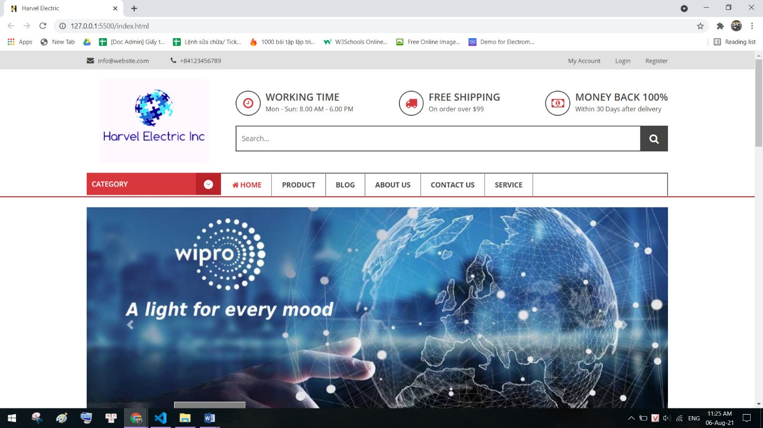

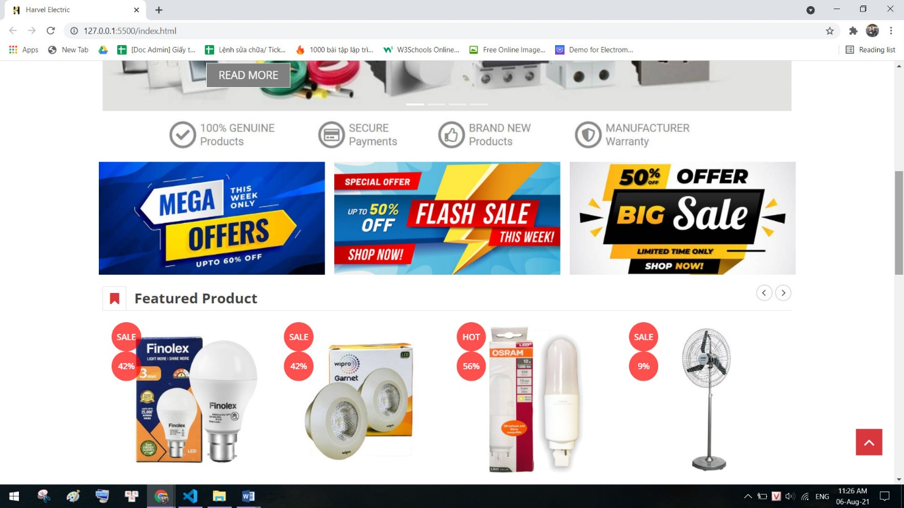

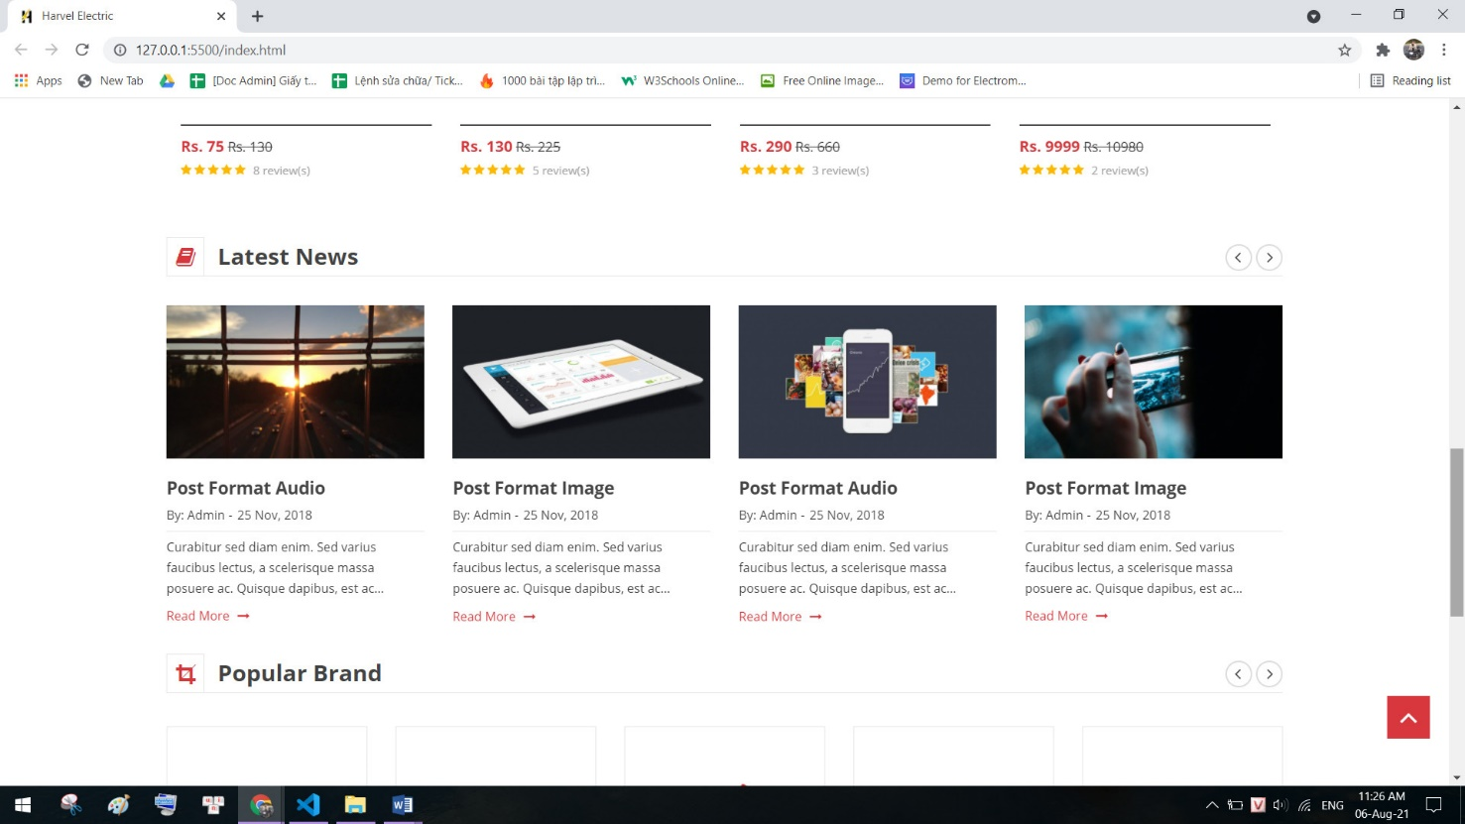

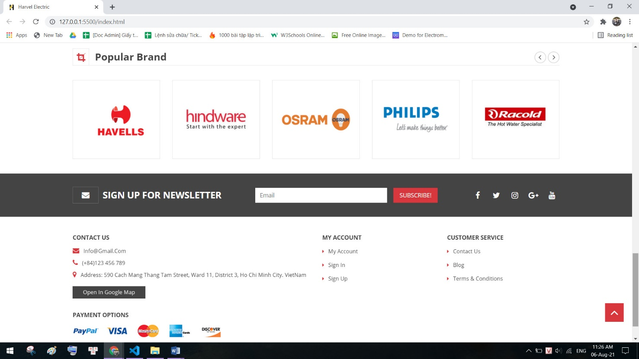

1. **Product**
2. Description

This product page displays following information:

- All product that being sold at Harvel Electric (LED & Lighting, FANs, Cables & Wires, Switches & Automation, Protection Devices, Appliances), when click on quick view item, it will show the detail of that item.

- Products can be compared with products of the same category

- Menu filter to easily find items based on categories.

- Product can sort by price and by name.

1. Screen shot

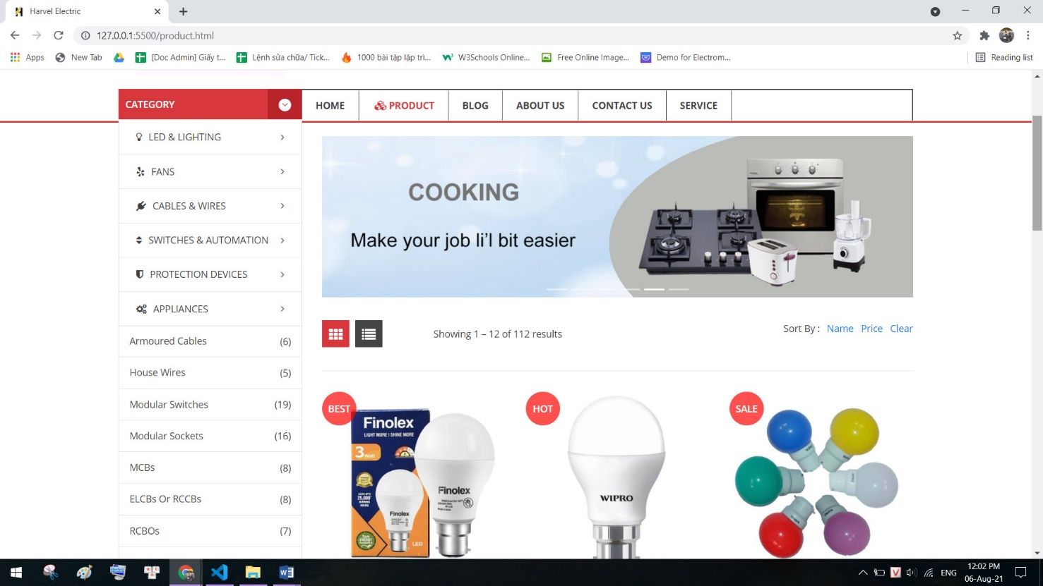

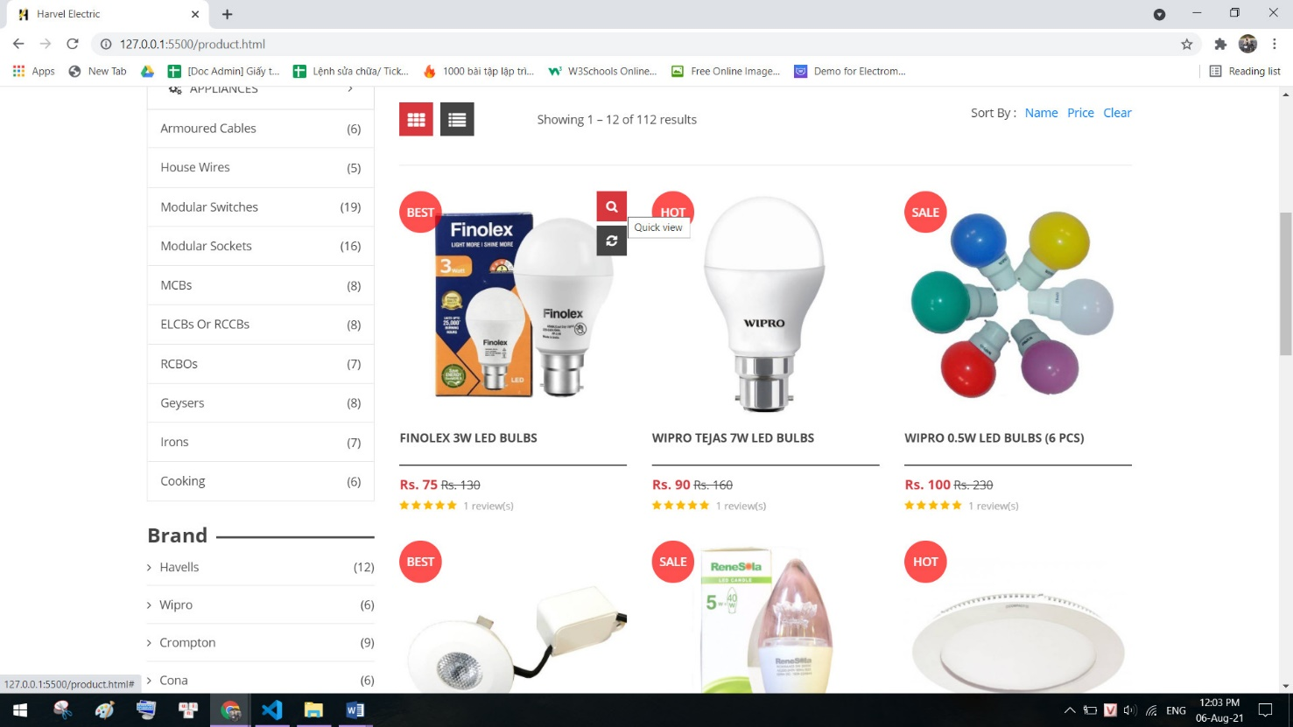

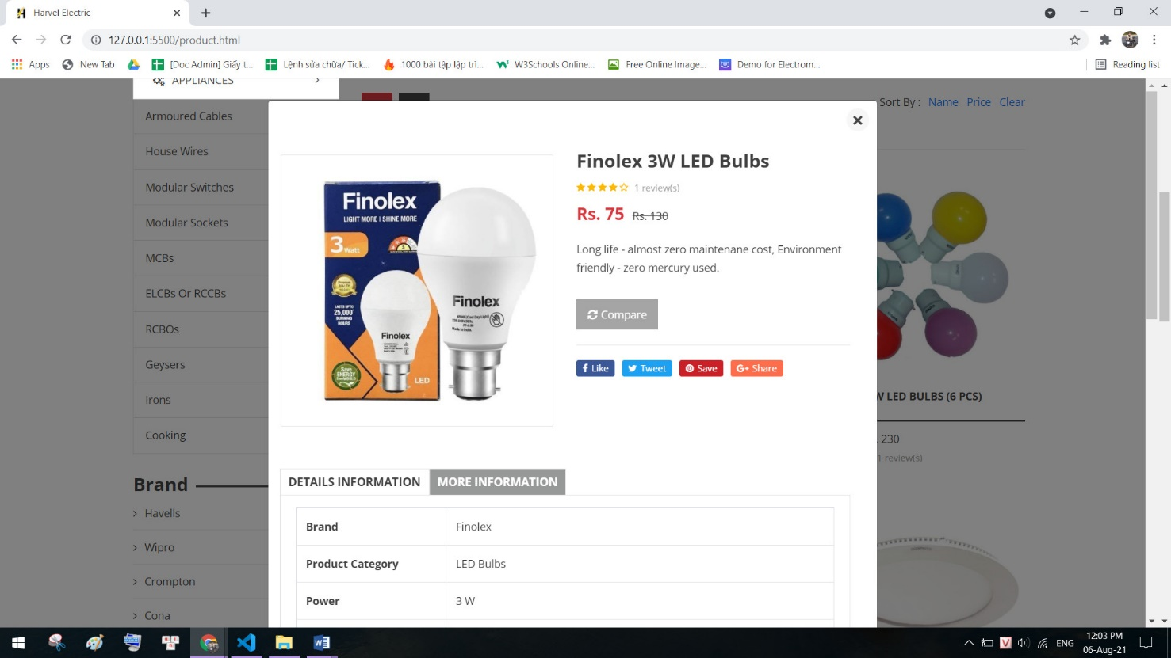

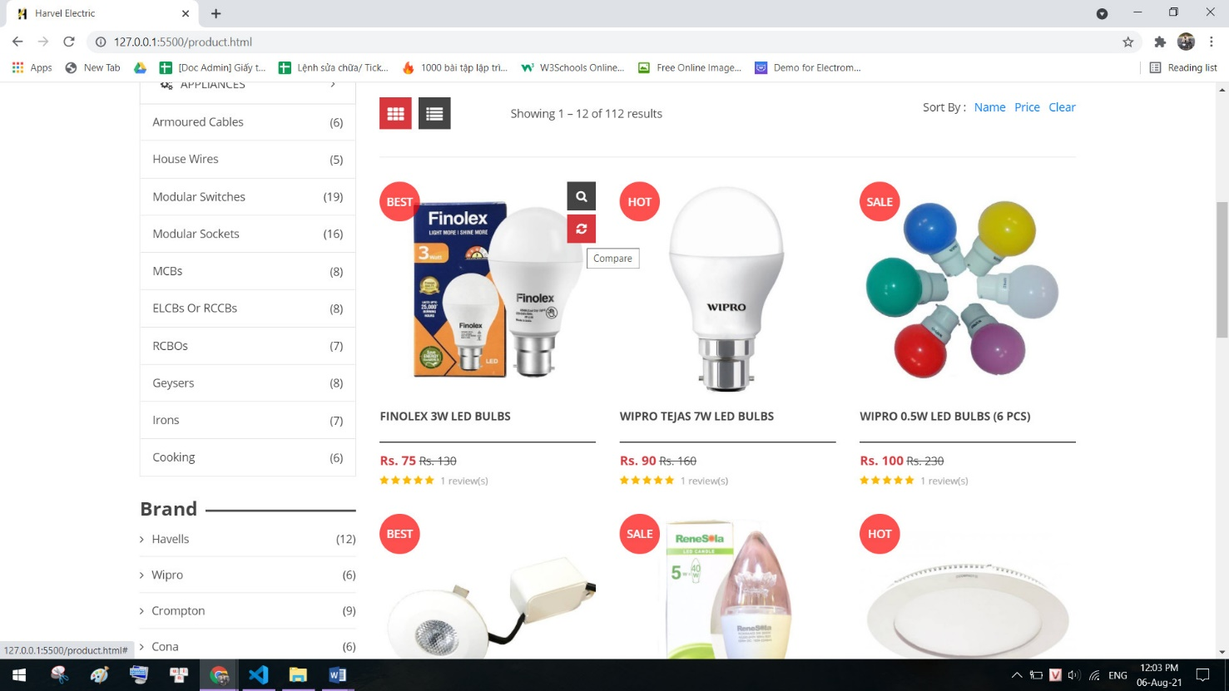

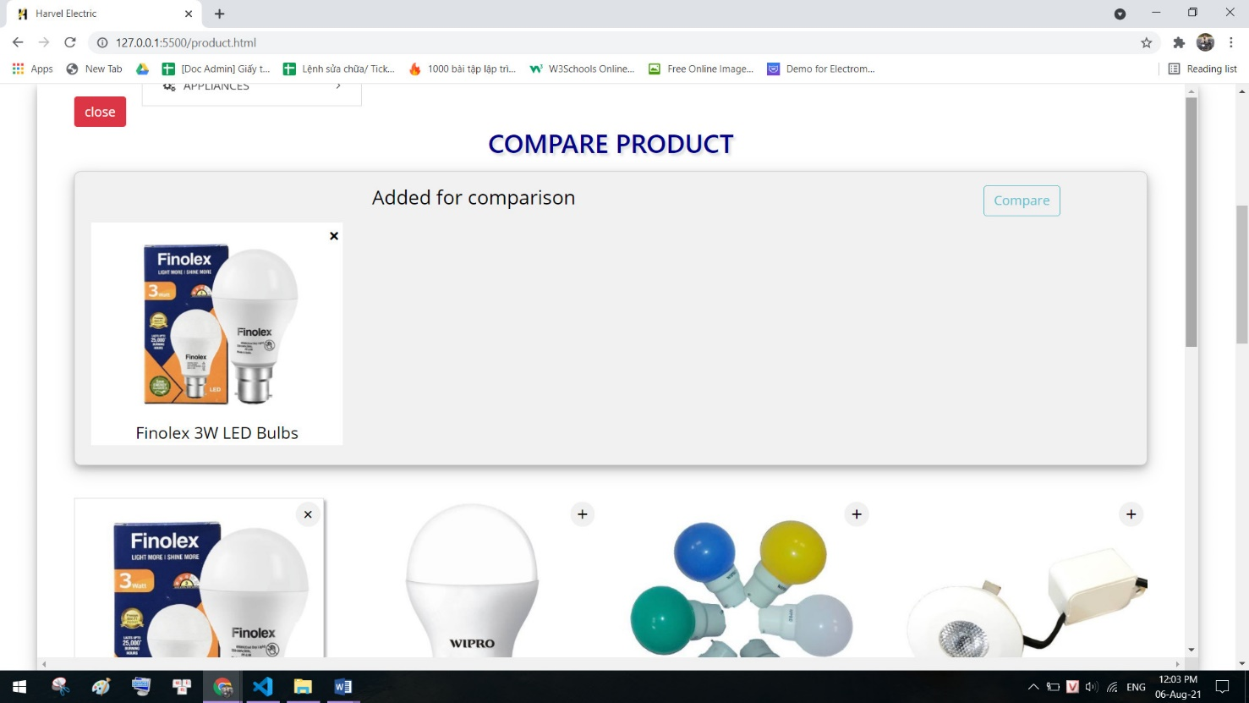

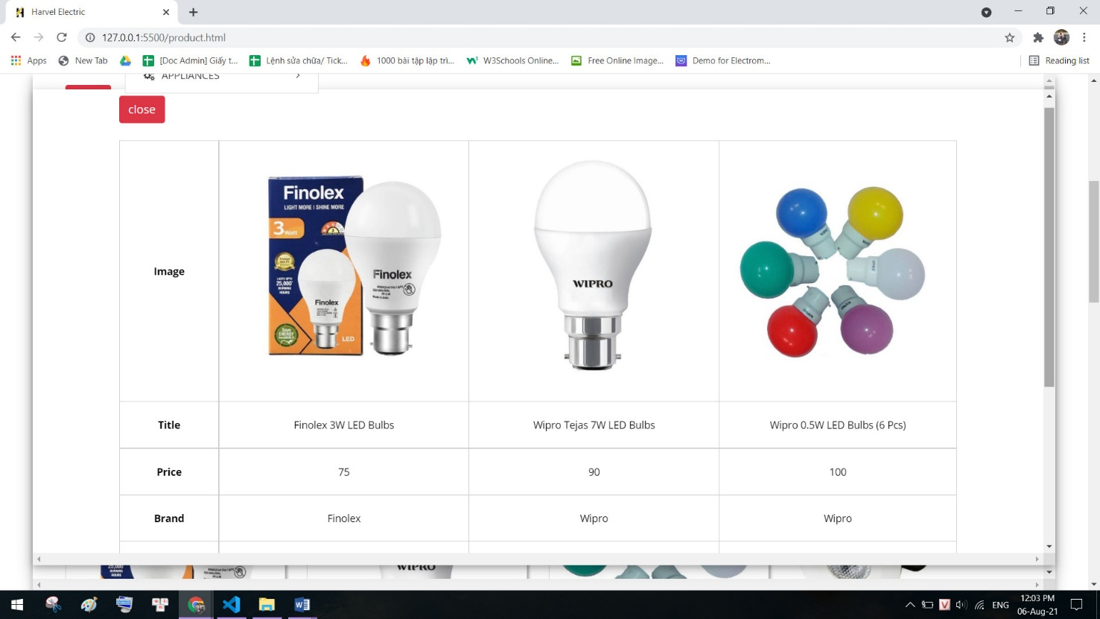

1. **Blog**
2. Description

The blog page displays following information:

- News.

- Information of product.

- Events, promount.

1. Screen shot

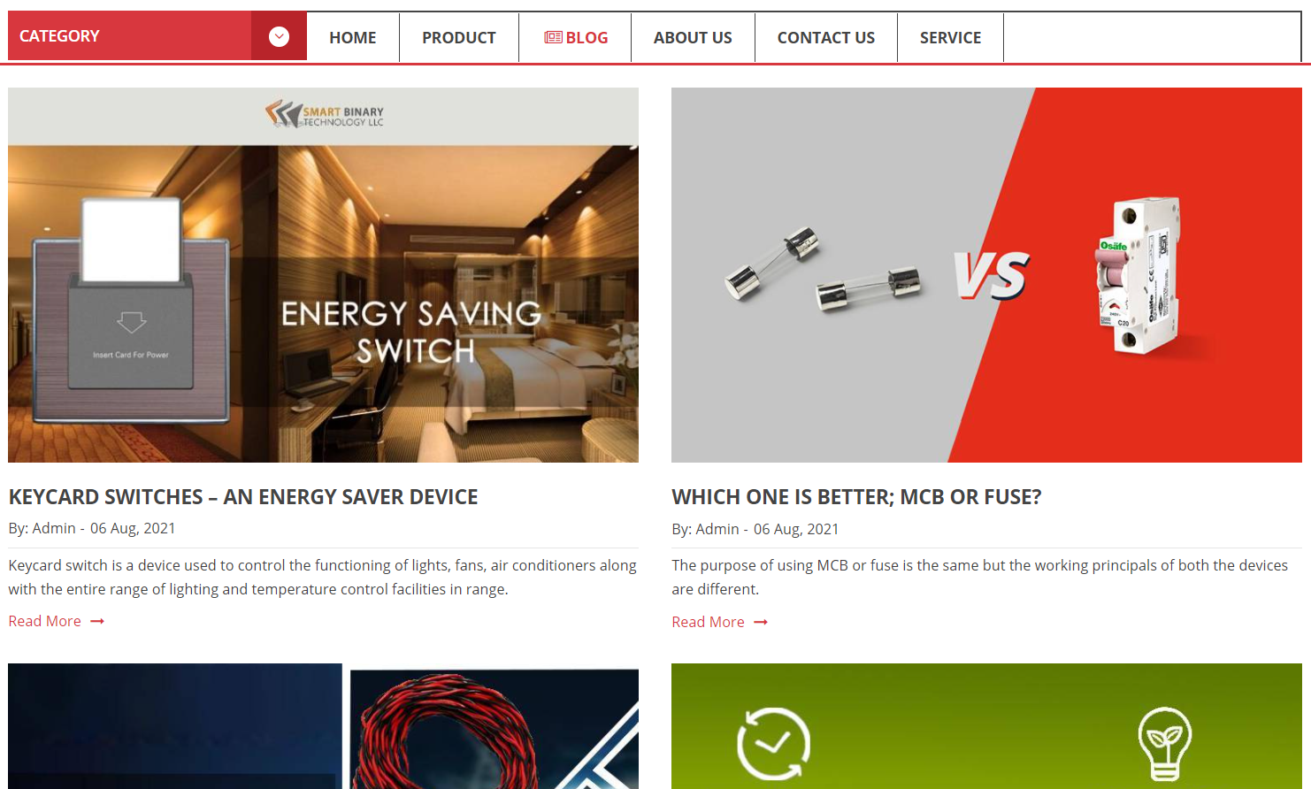

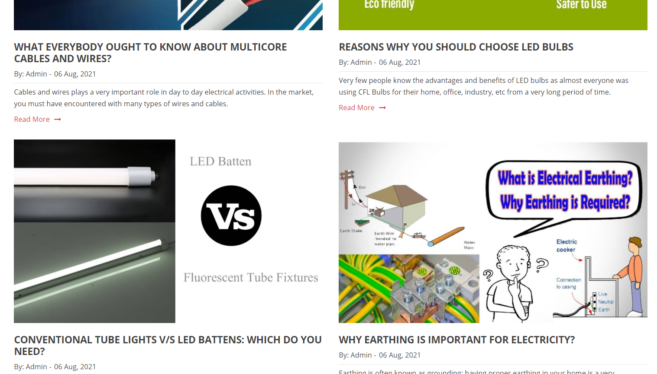

1. **About Us**
2. Description

- This page displays information about the history of Rhythm House, our service that we provide and our team member.

- Display happy customer.

1. Screen shot

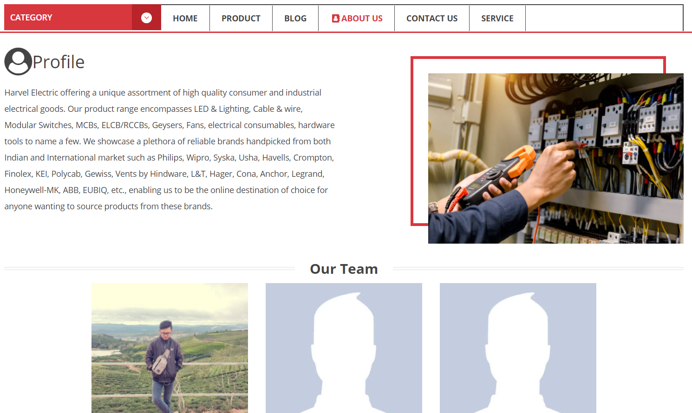

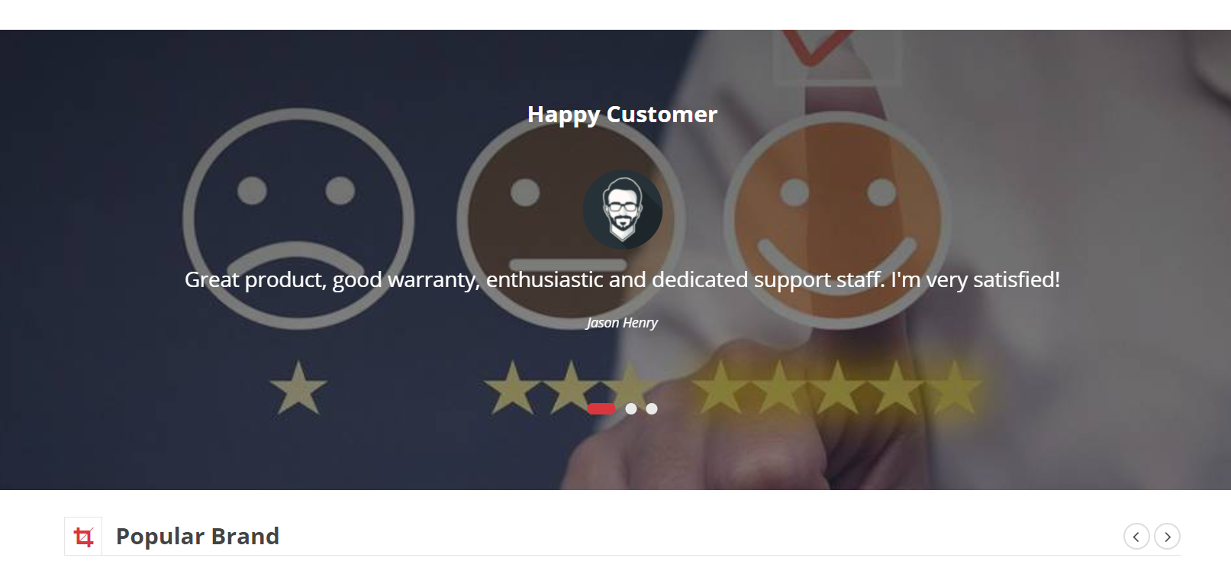

1. **Contact Us**
2. Description

This page displays contact information: location, telephone number, email and a quick contact form for customer

1. Screen shot

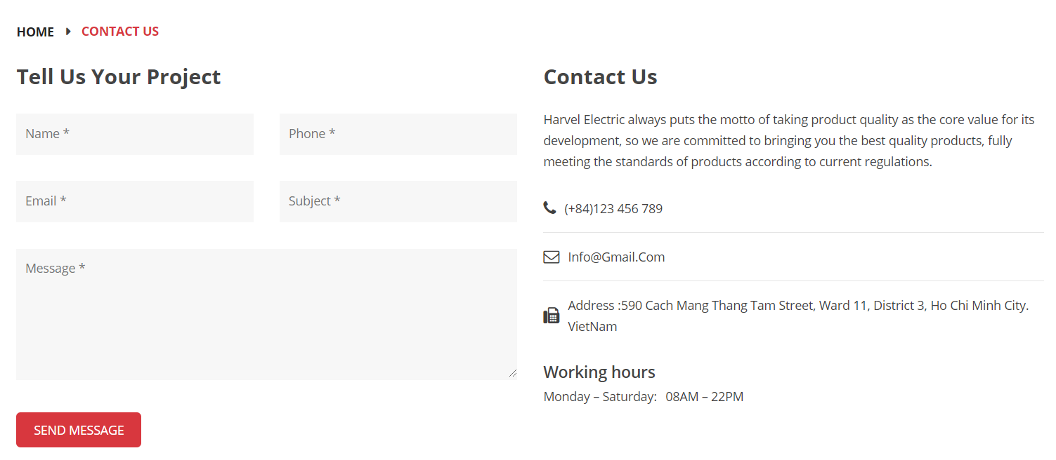

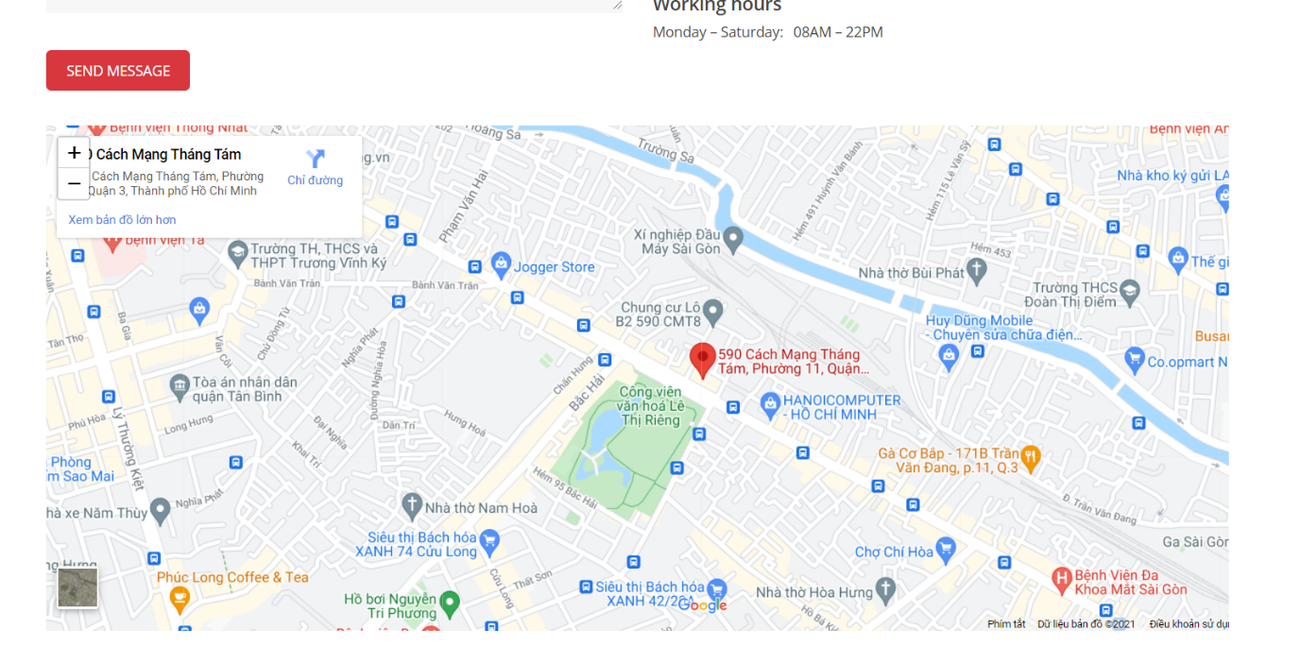

1. **Service**
2. Description

- This page displays information: Warranty terms, information, review about product.

- User can download product data.

1. Screen shot

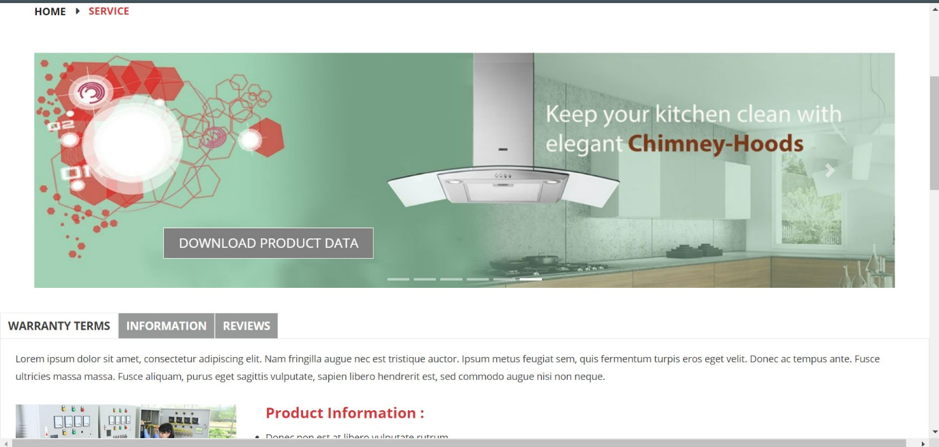

1. **Login/ Register**
2. Description

- This page displays information: Warranty terms, information, review about product.

- User can download product data.

1. Screen shot

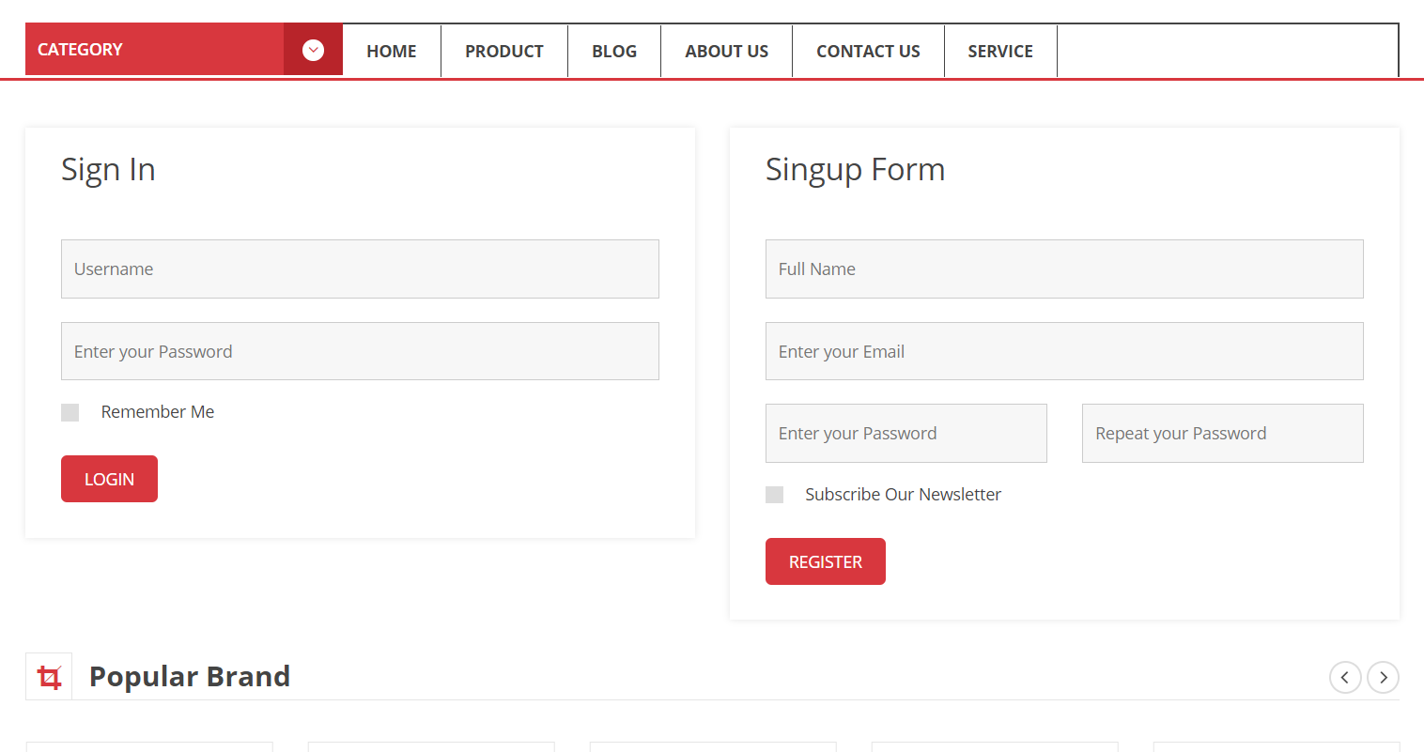

**RESPONSIVE**

The page has responsive feature for small screen device such as smart phone, tablet, etc.

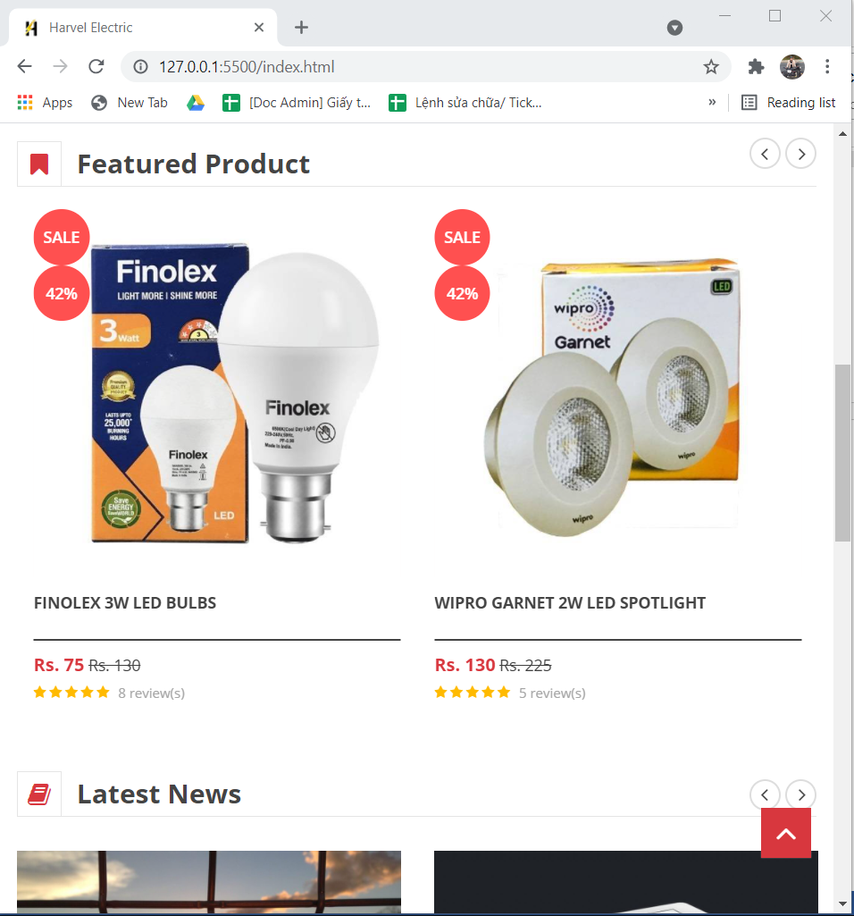

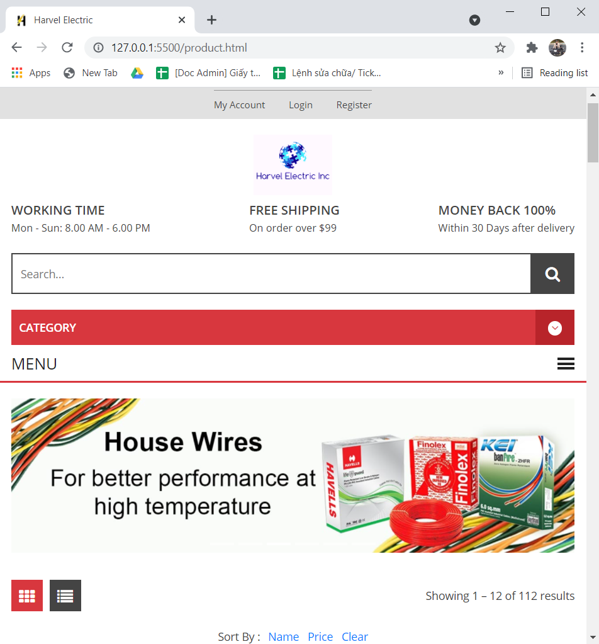

**JAVASCRIPT DESCRIPTION**

1. **Slider Javascript**
2. Description

This script used slick package (carousel) to display the products on the website.

1. Screen shot

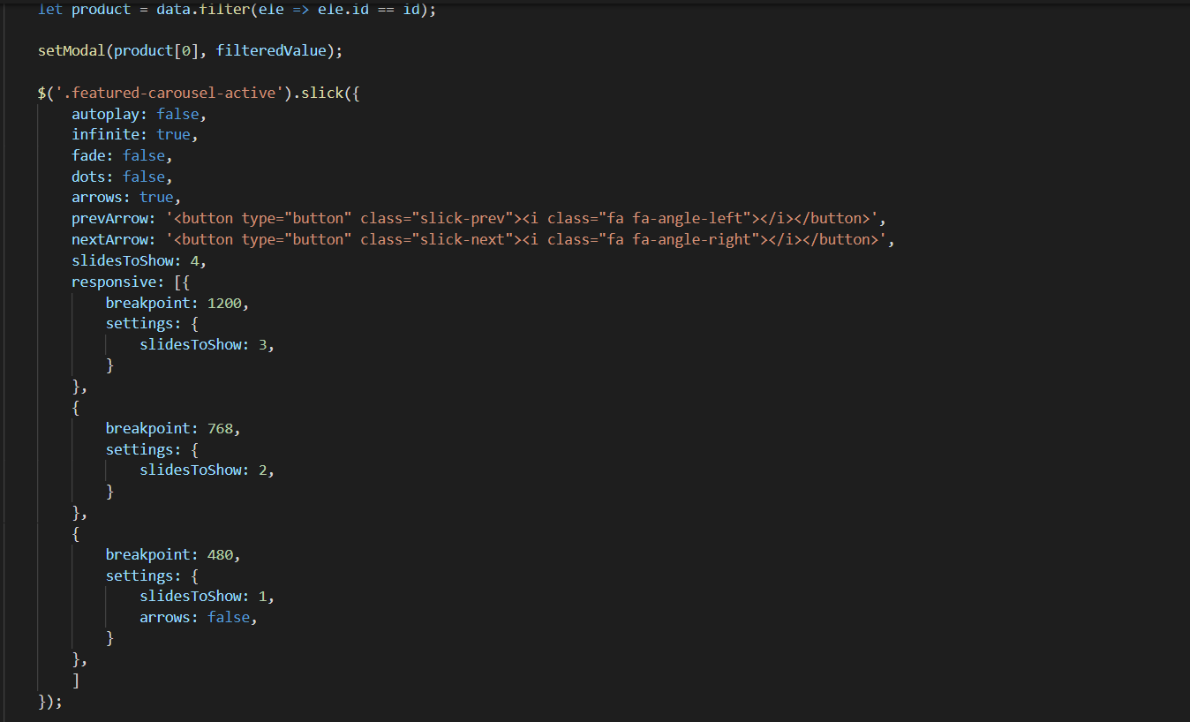

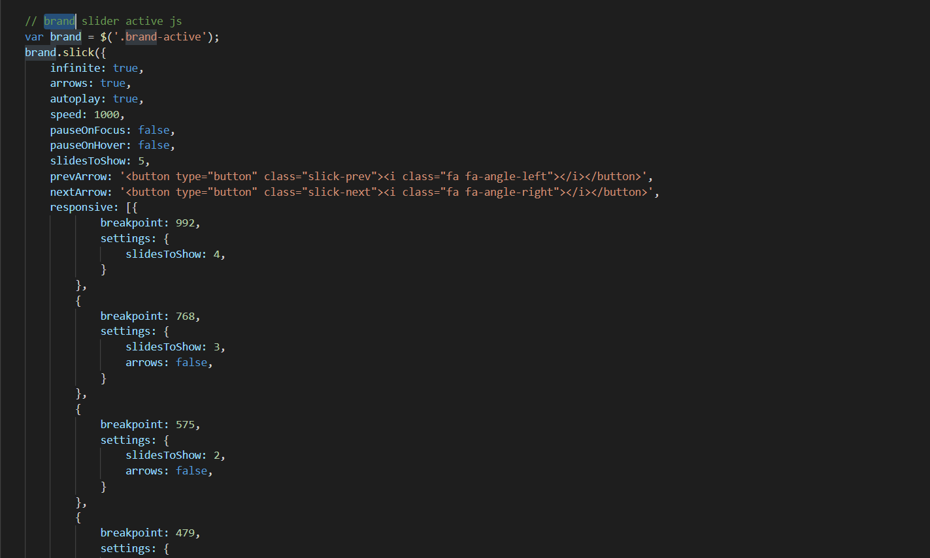

1. **Filter Javascript**
2. Description

This script is used to filter the product list by Type, Brand, Feature, Tag.

1. Screen shot

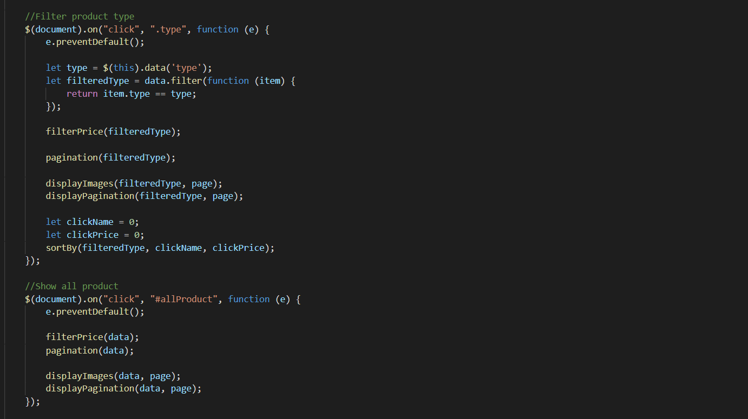

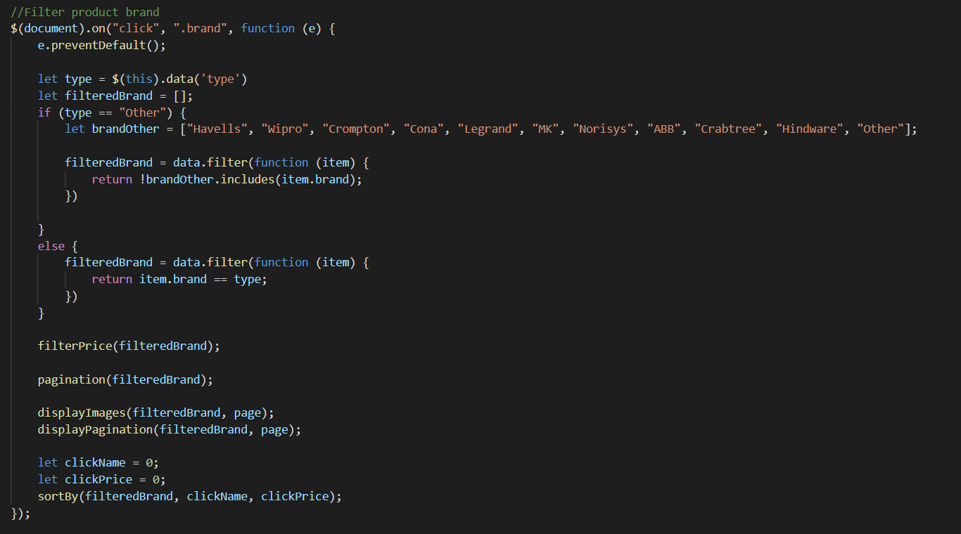

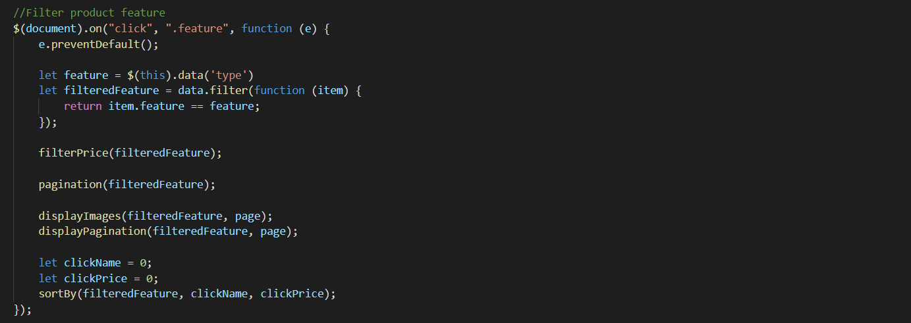

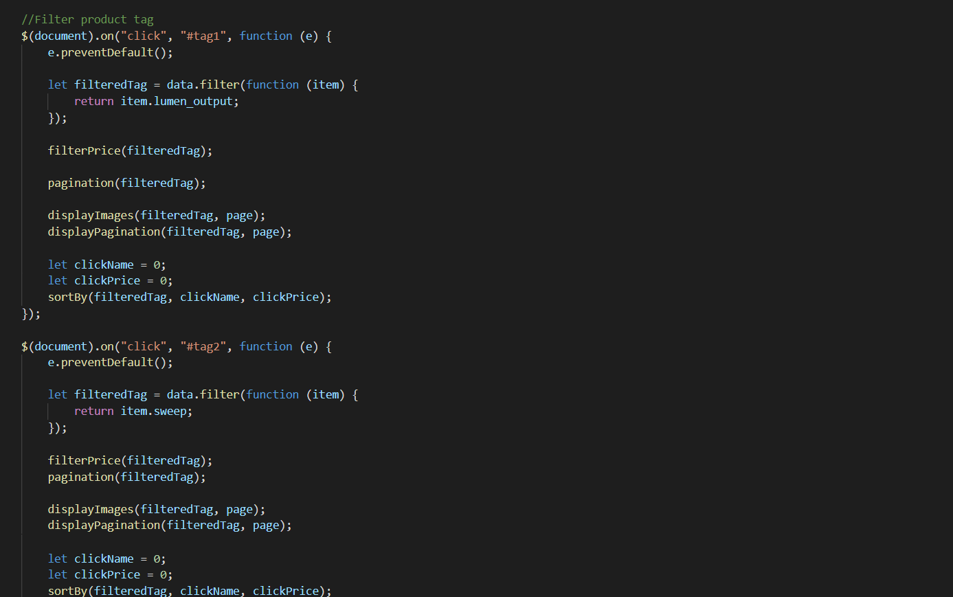

1. **Filter Price Javascript**
2. Description

- This script is used to filter the product list by Price.

- Users can adjust the price to filter products in the selected price bracket

1. Screen shot

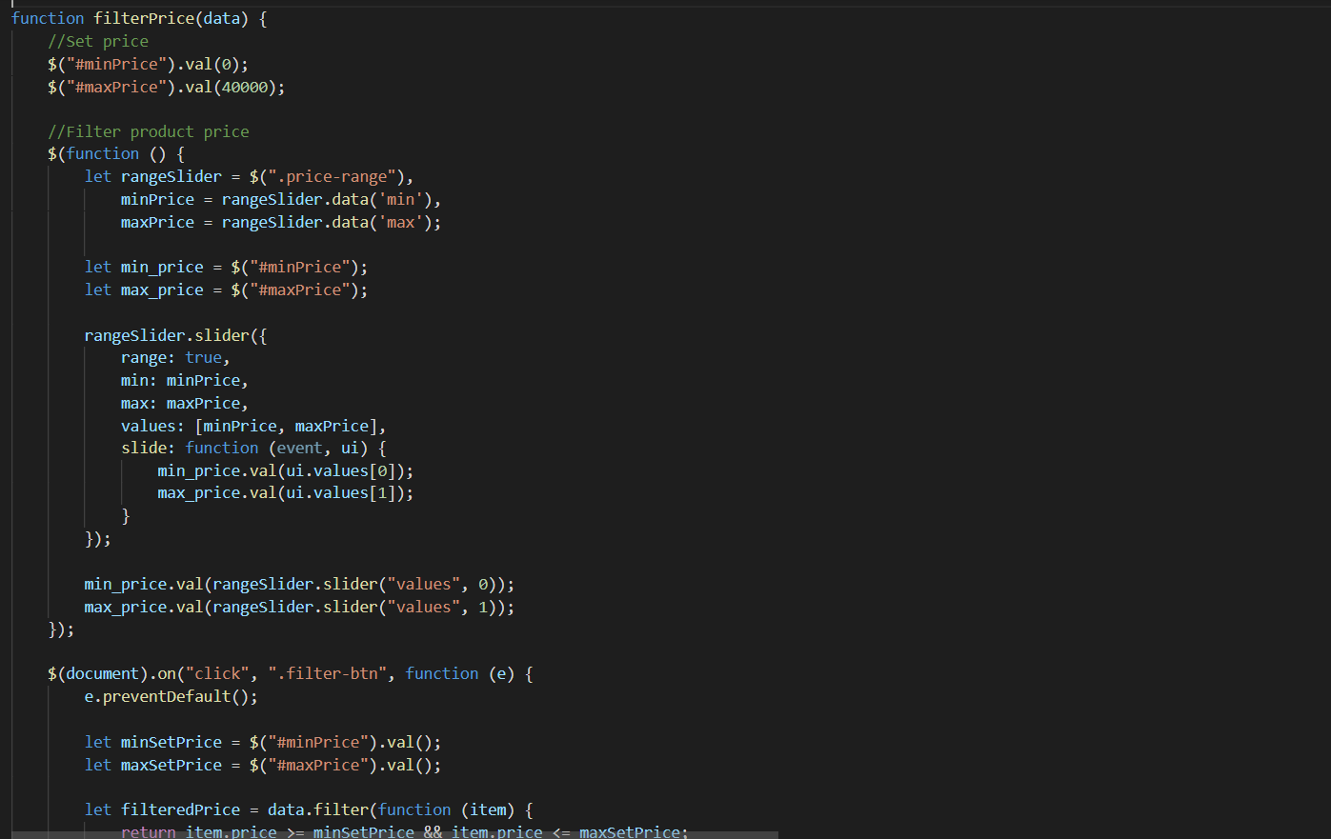

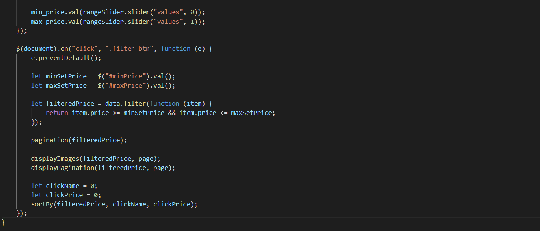

1. **Sort Javascript**
2. Description

This script is used to filter products by name or by price

1. Screen shot

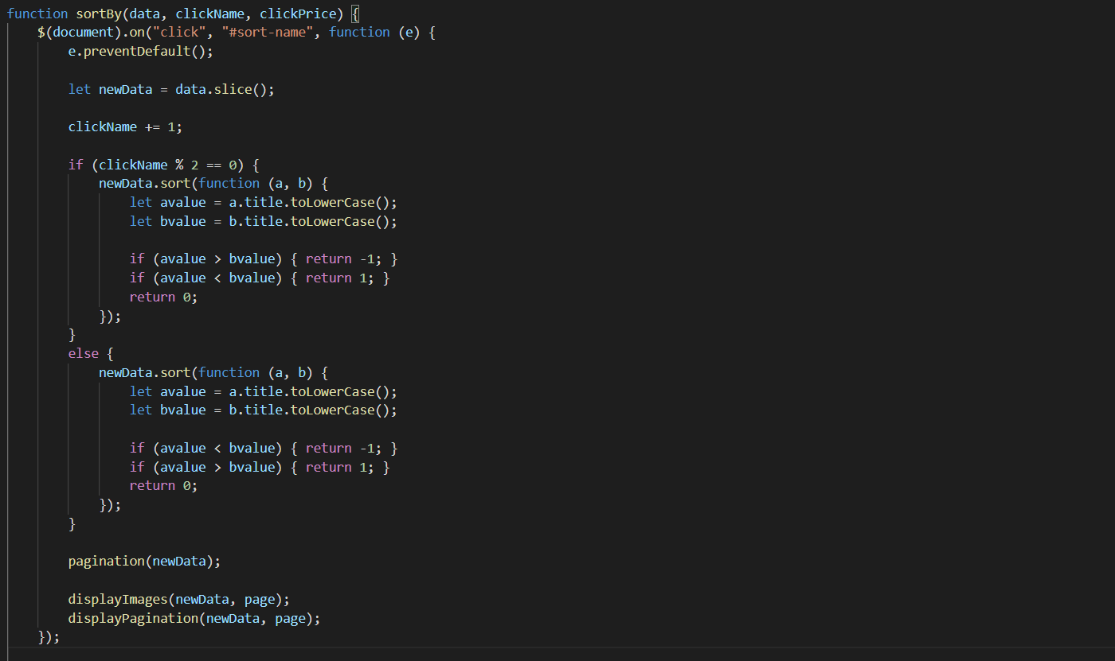

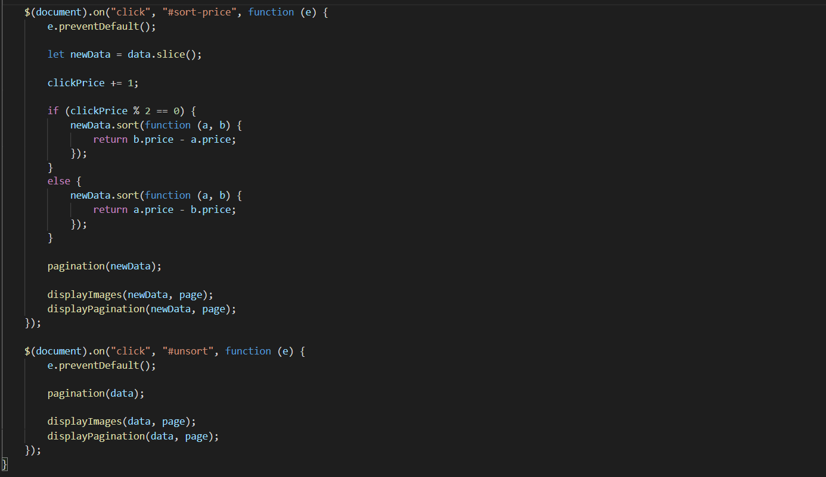

1. **Compare Javascript**
2. Description

This script is used to compare products of the same category

1. Sreen shot

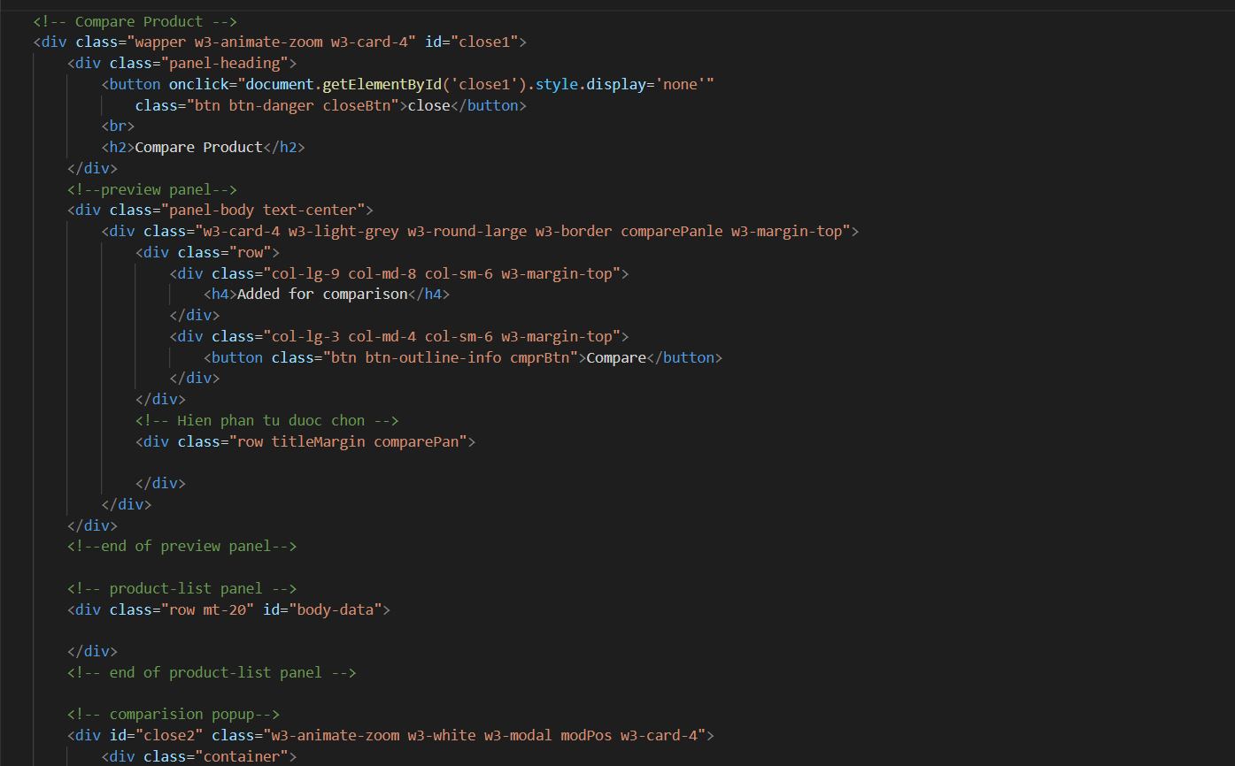

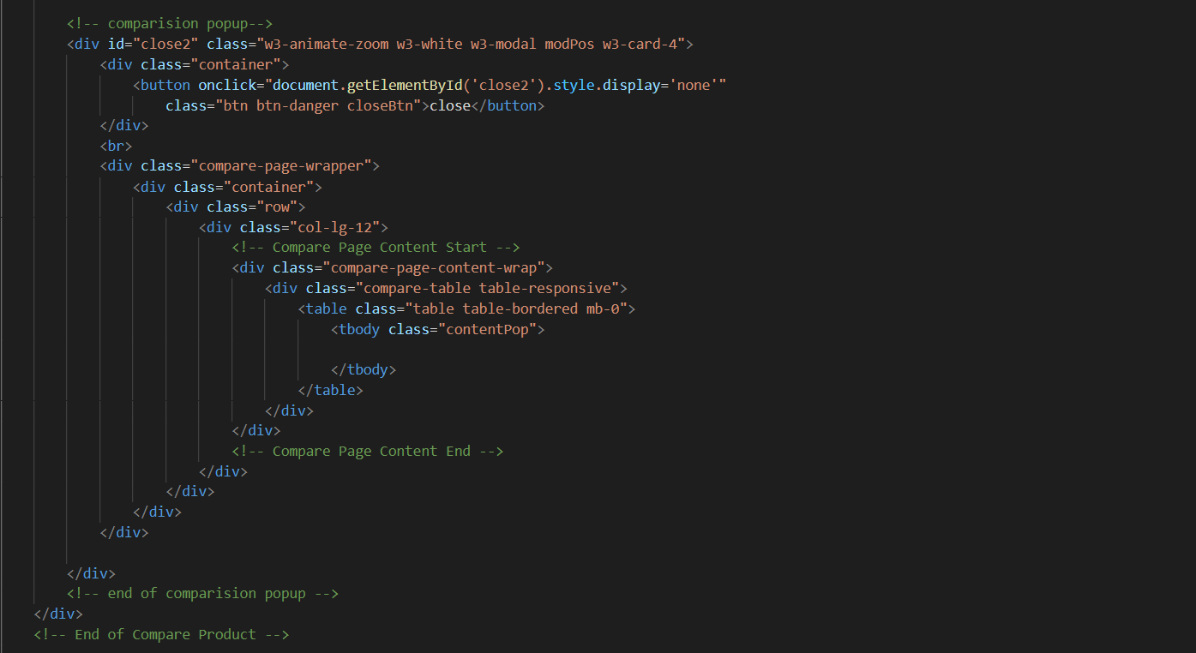

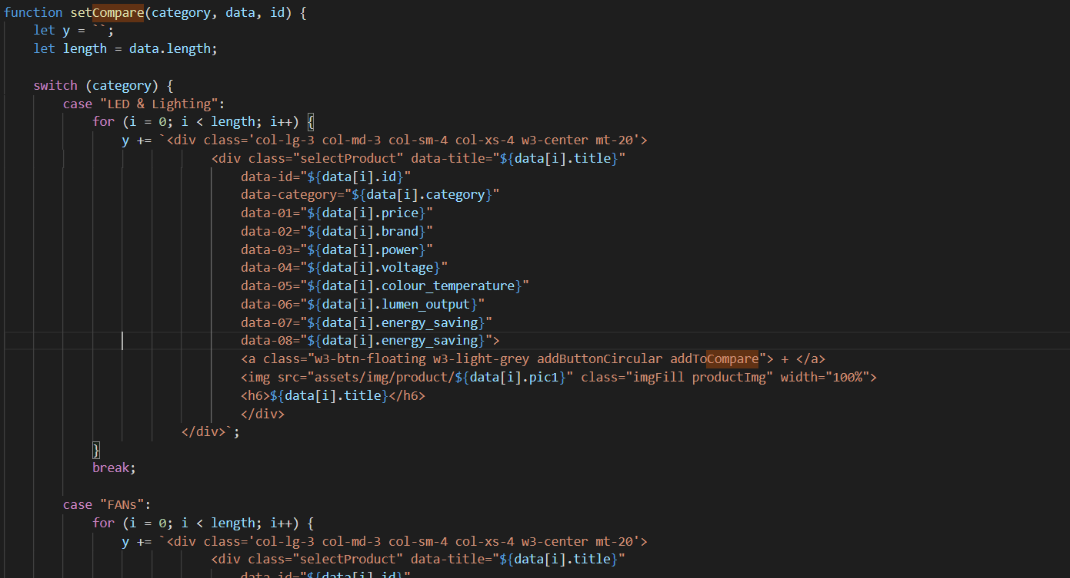

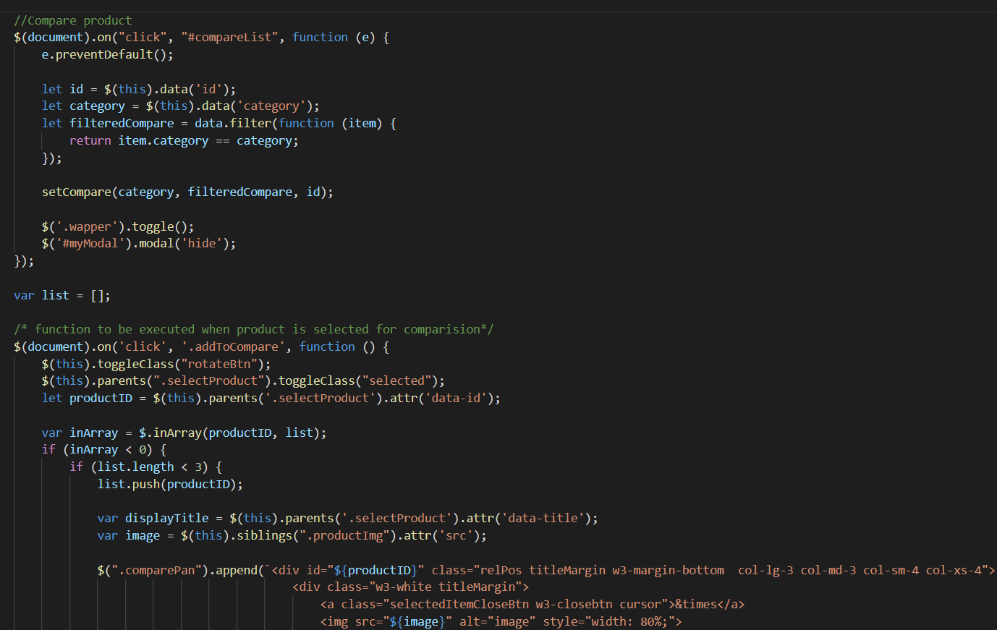

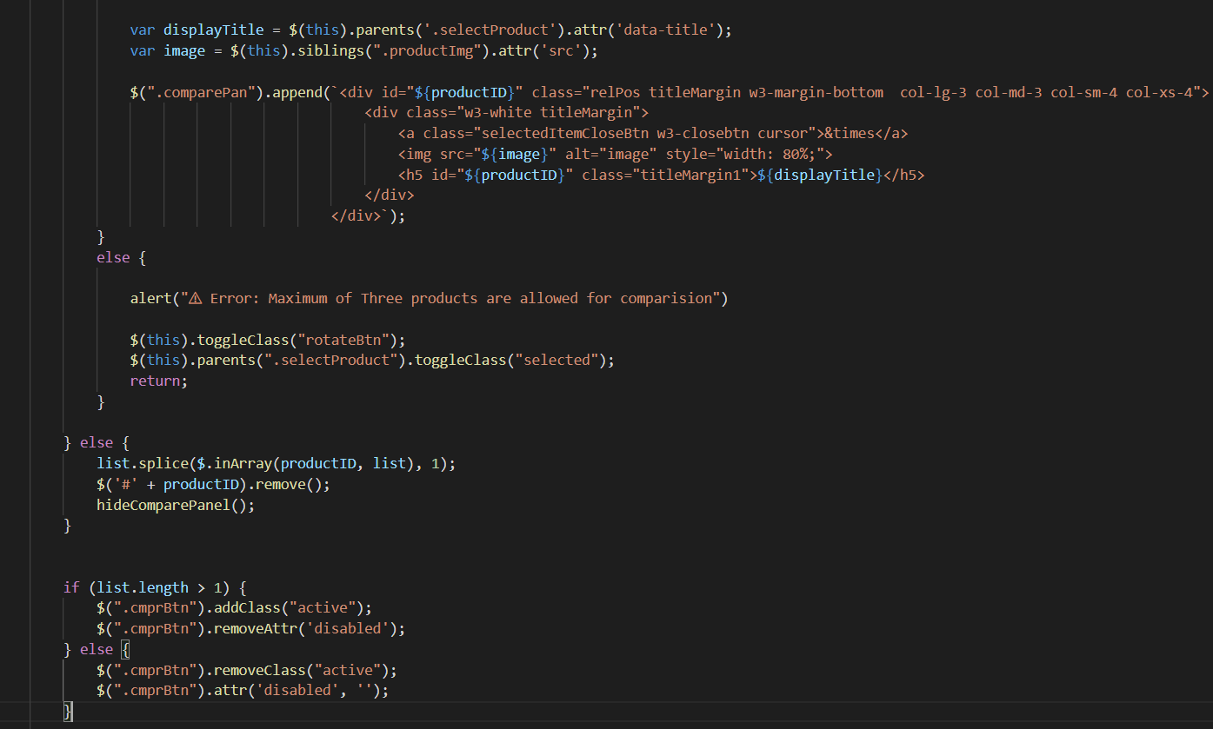

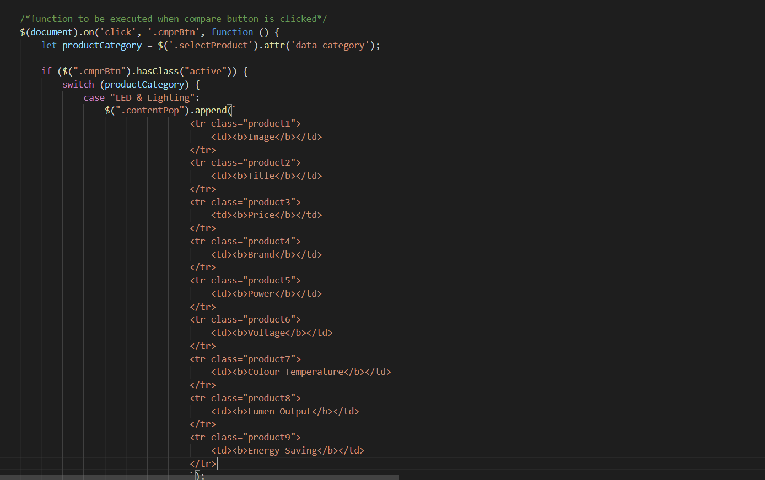

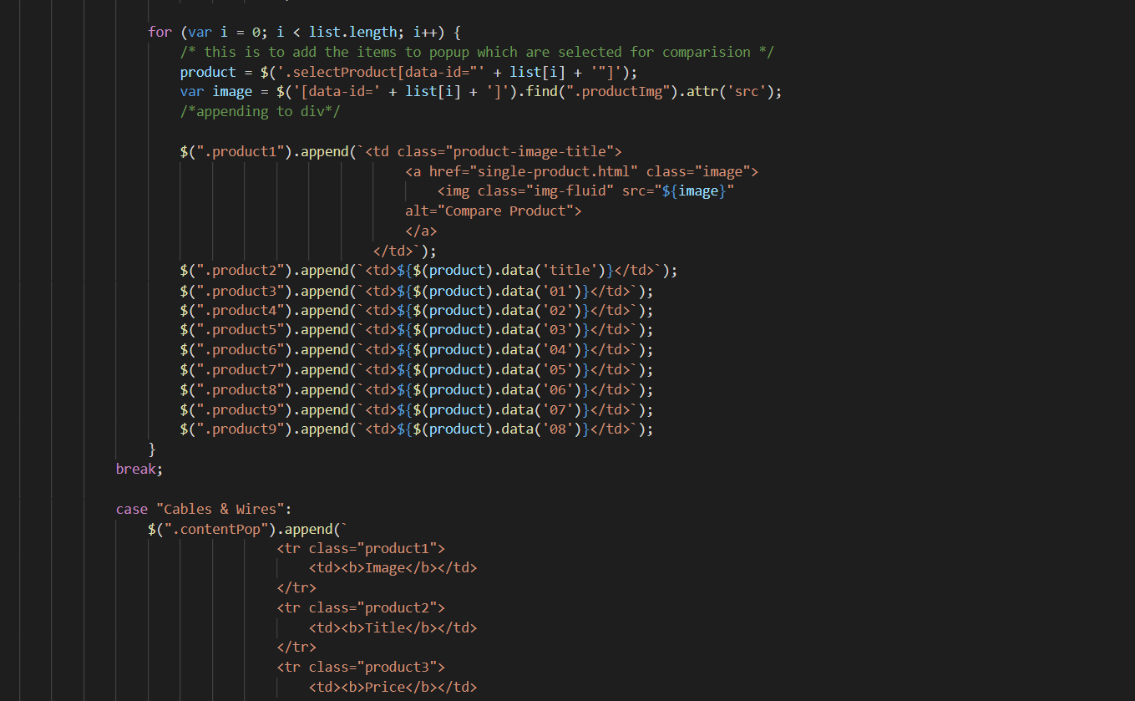

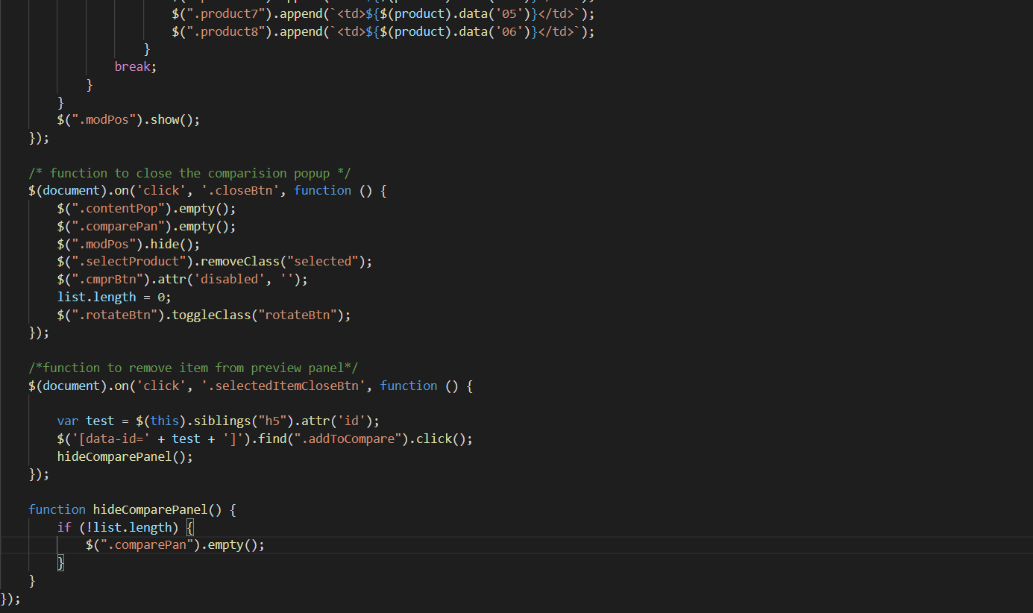

1. **Pagination Javascript**
2. Description

This script is used to paginate products into pages, each with twelve products

1. Sreen shot

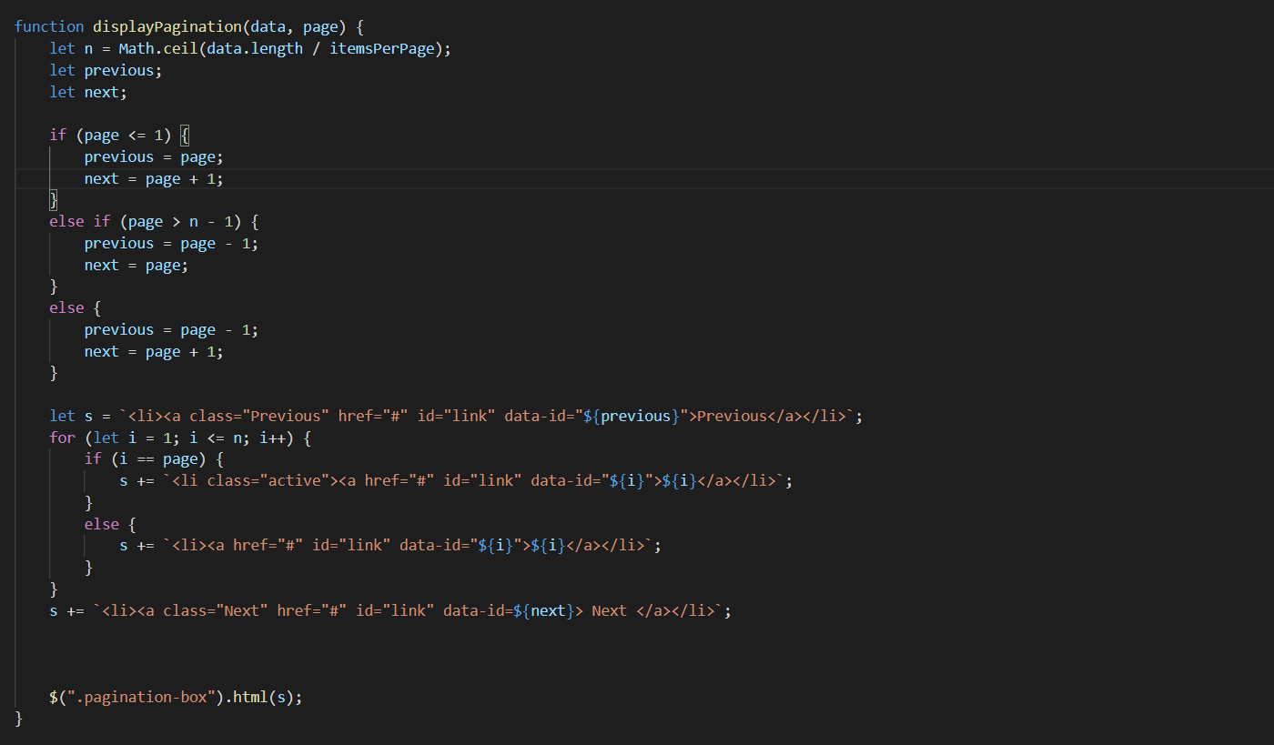

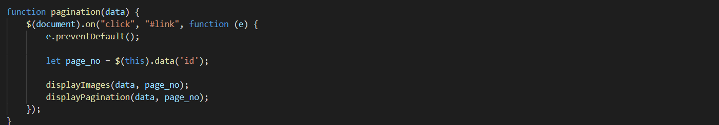

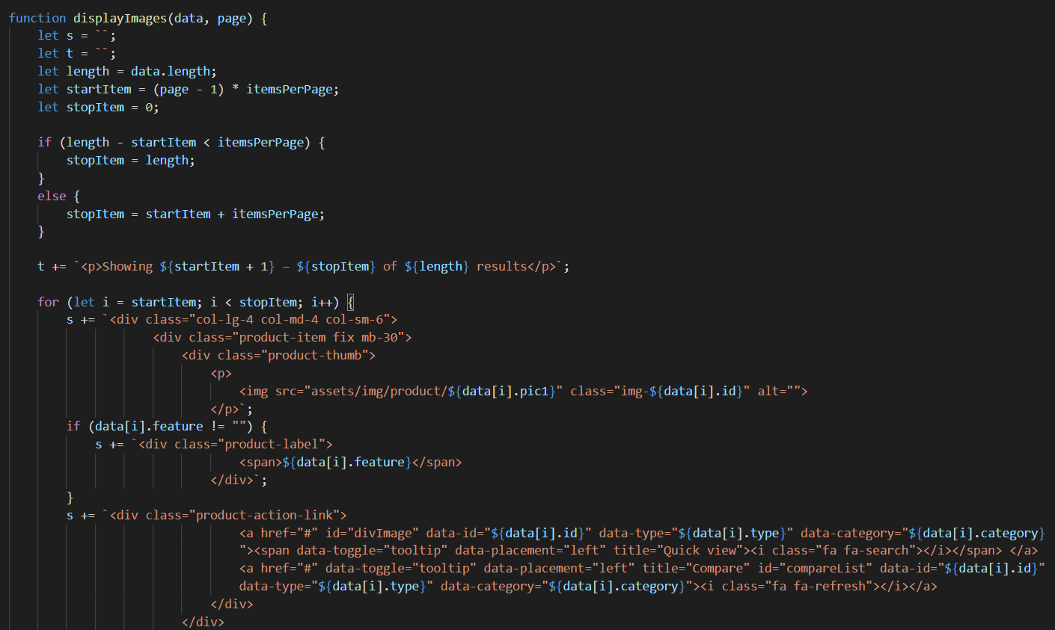

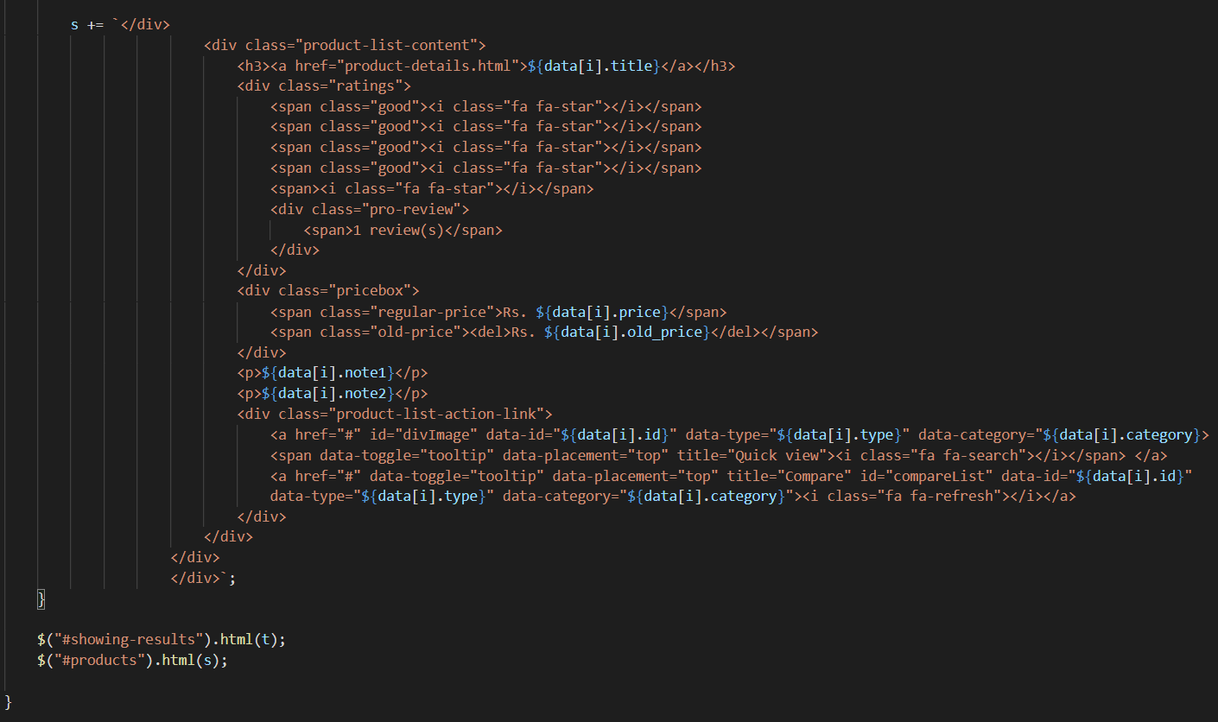

1. **Create Modal Javascript**
2. Description

This script is used to display product details in a modal format. Inside there are more products of the same type

1. Screen shot

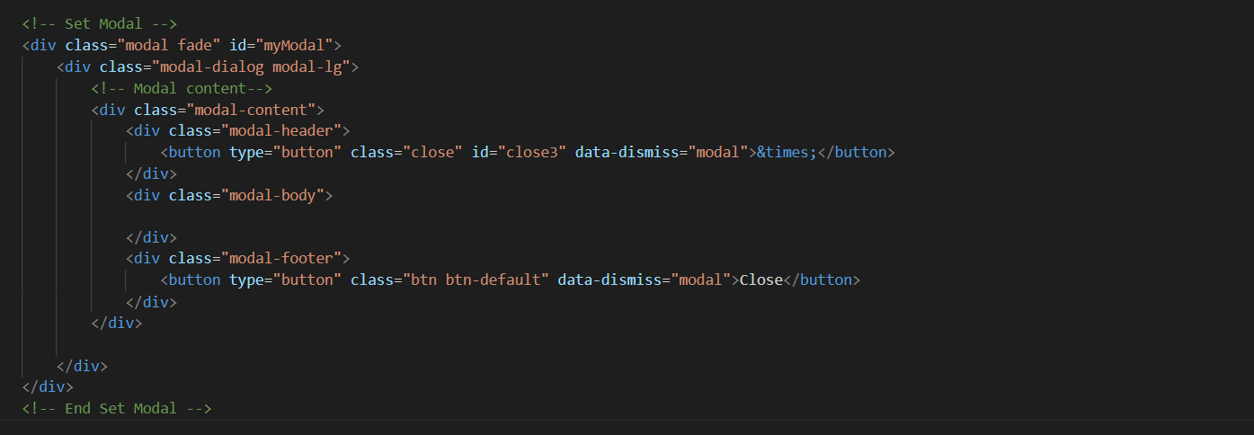

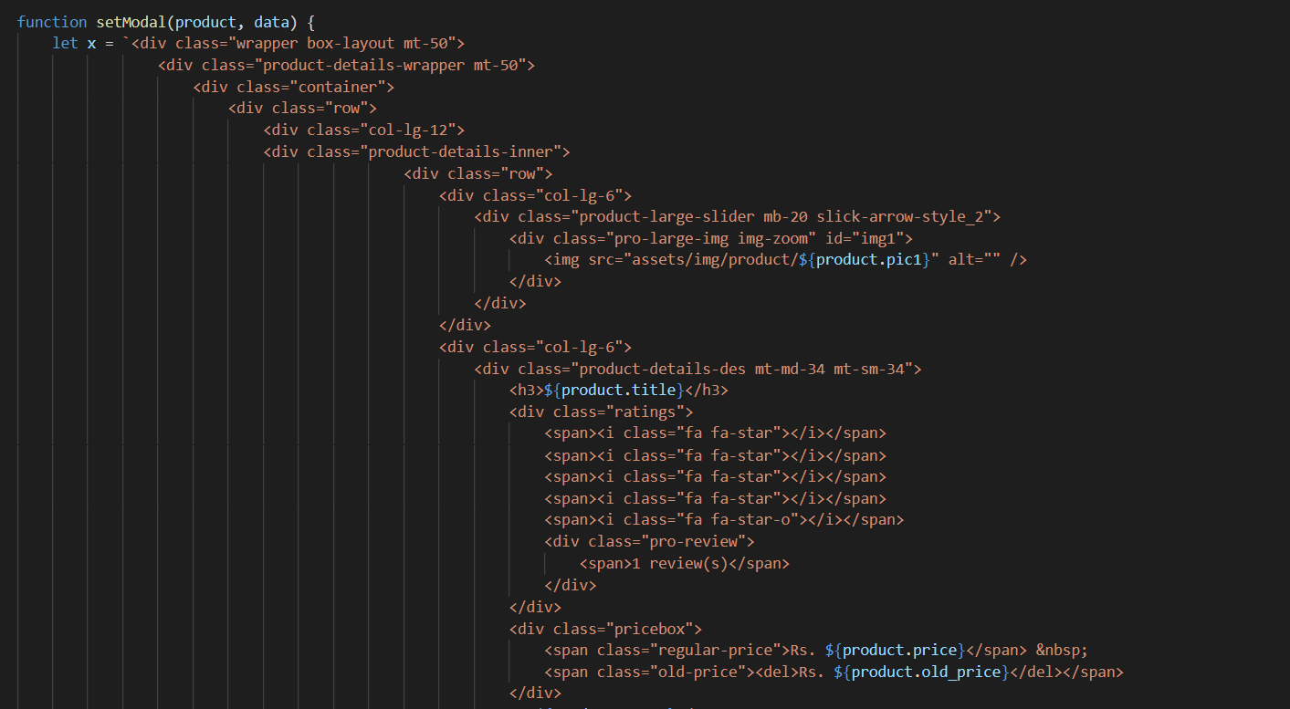

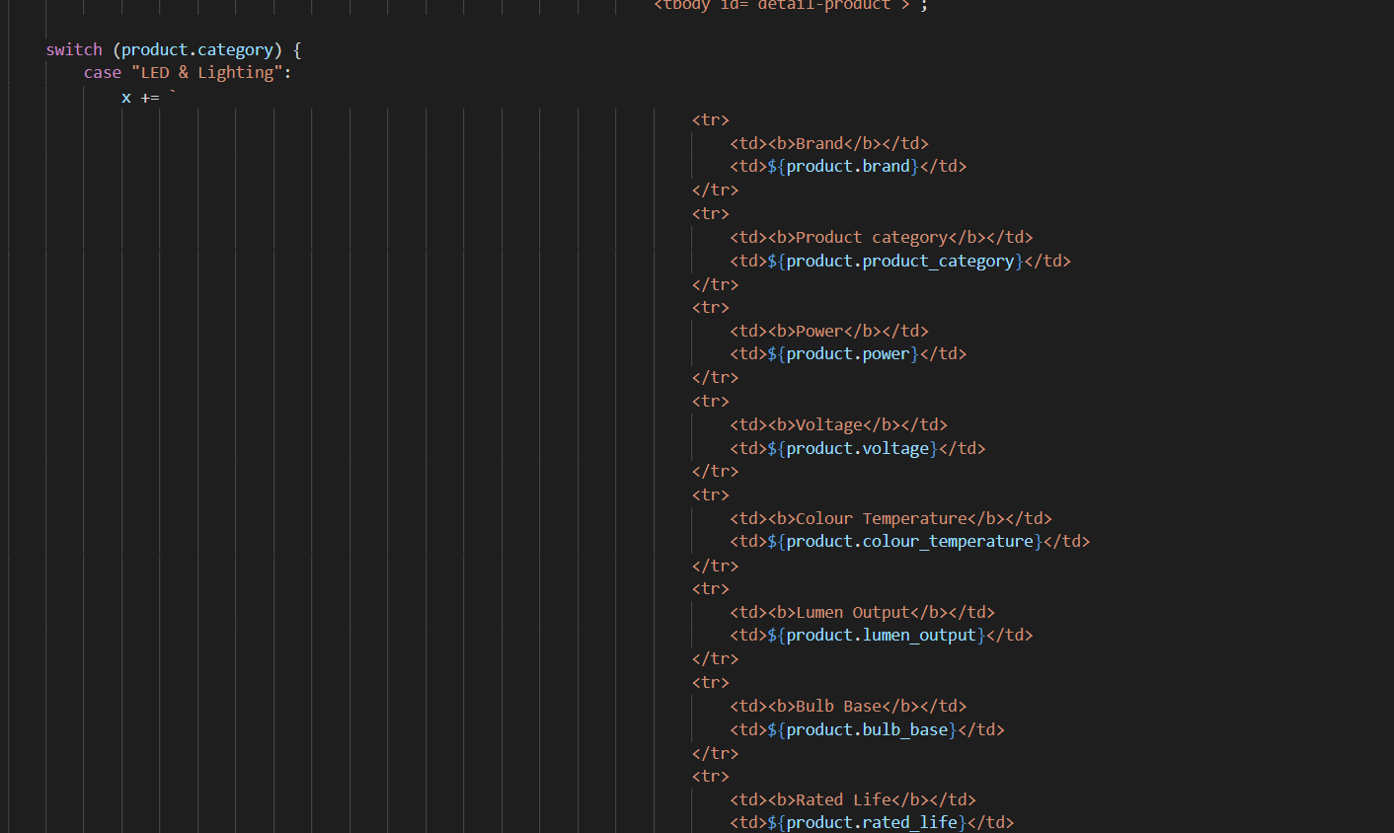

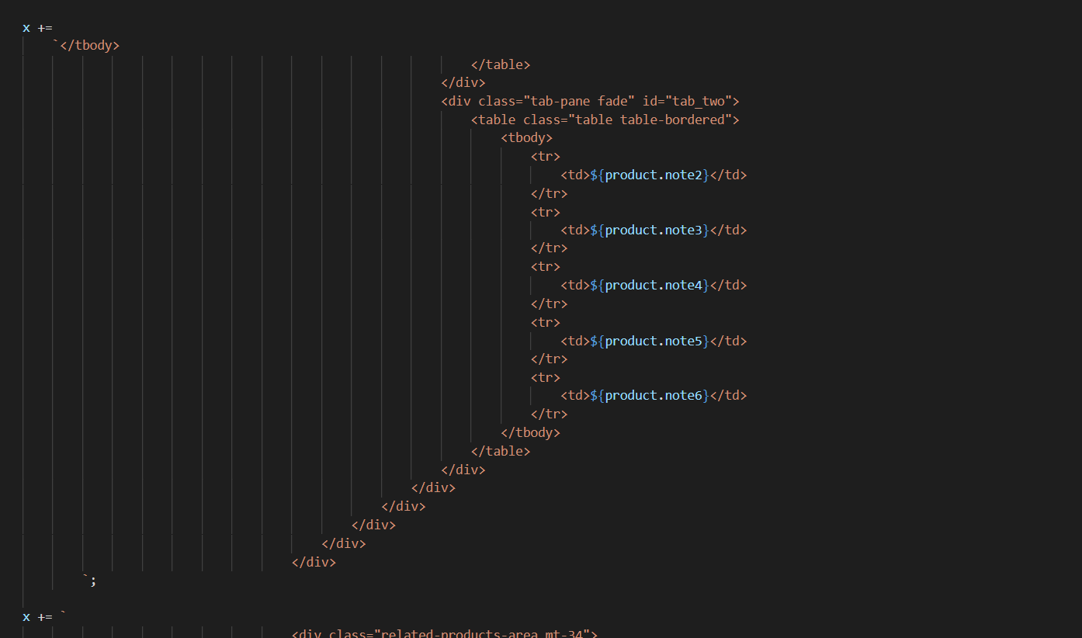

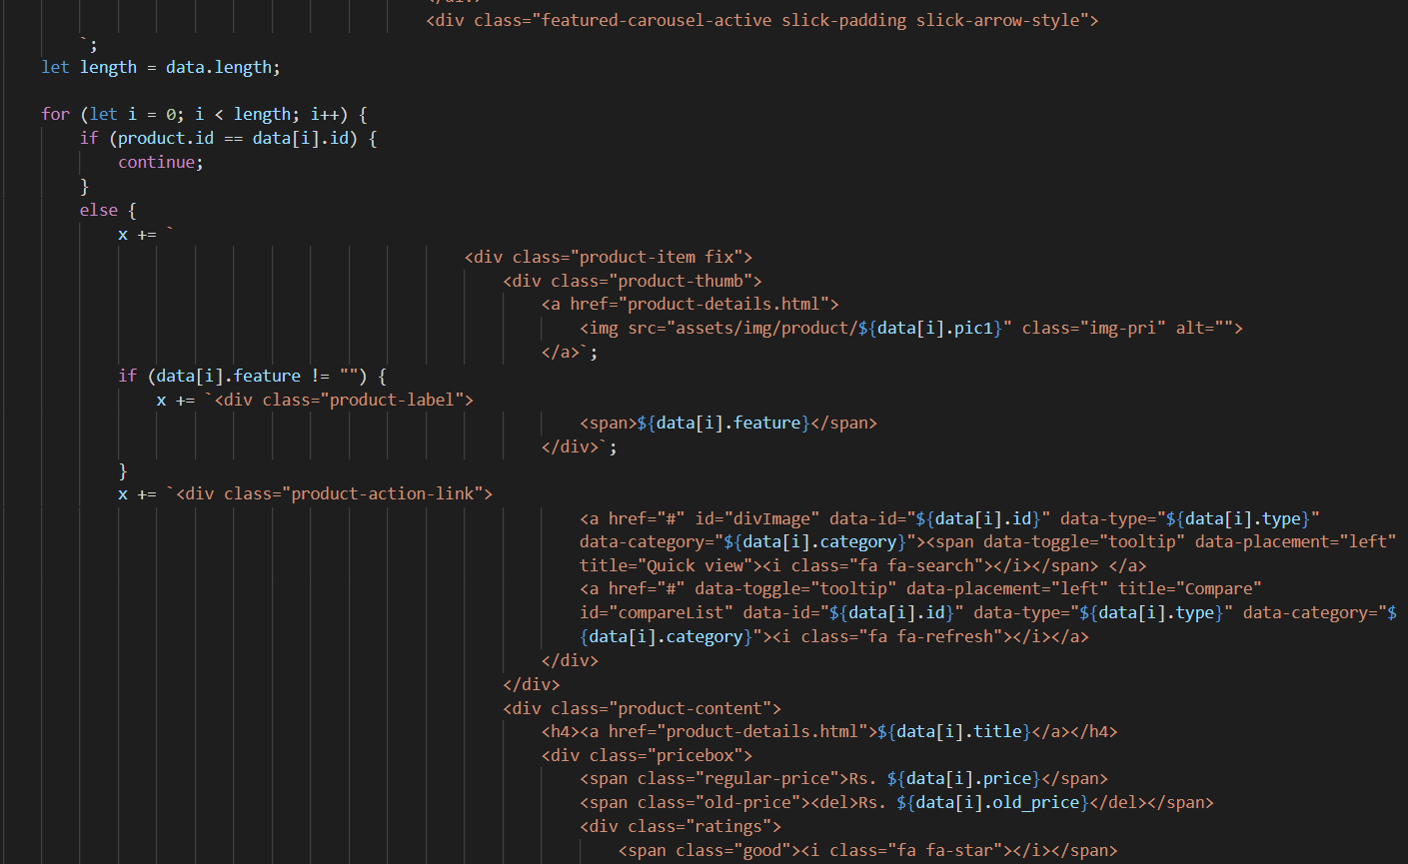

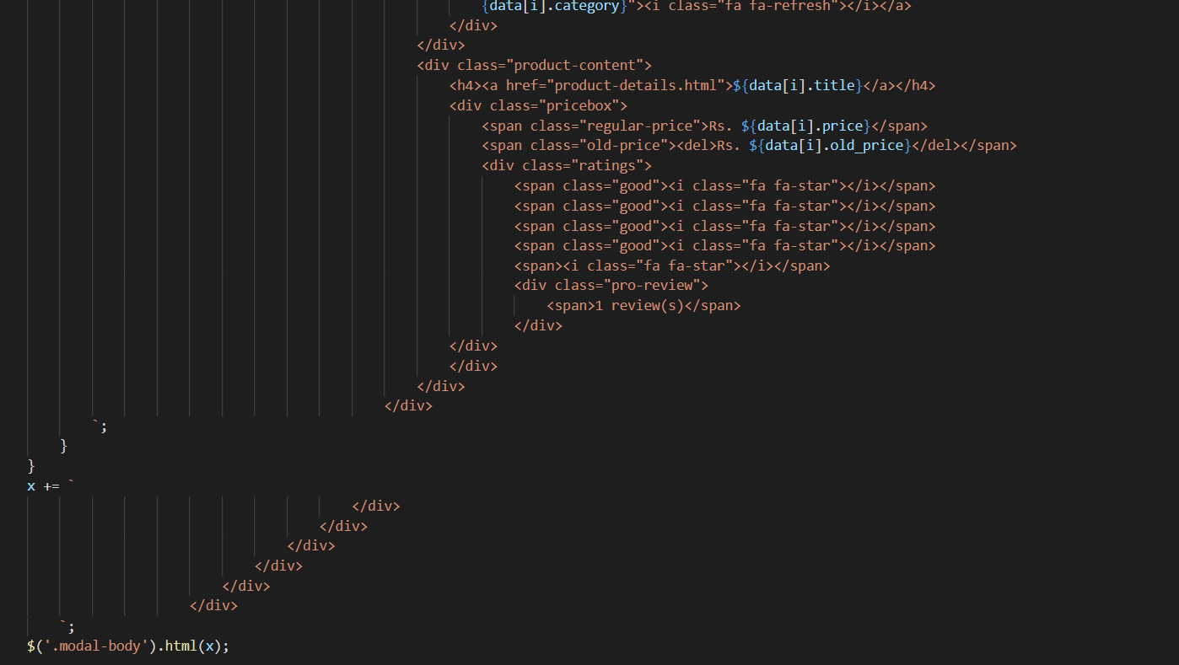

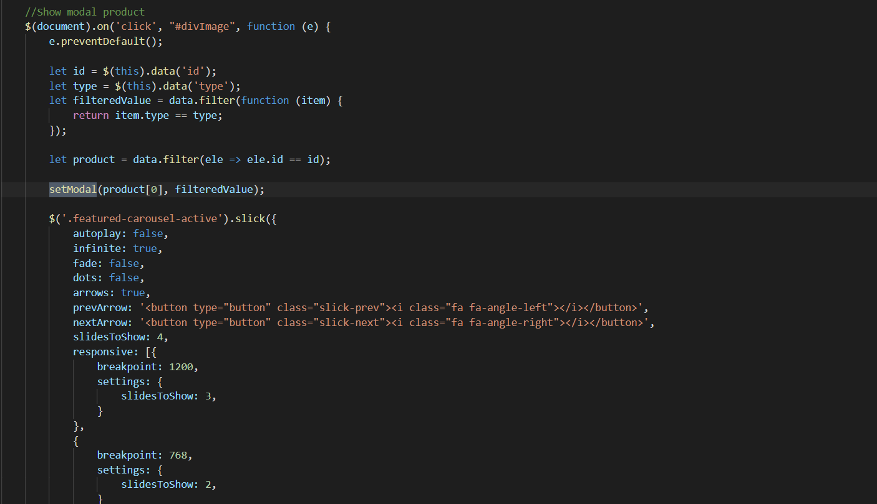

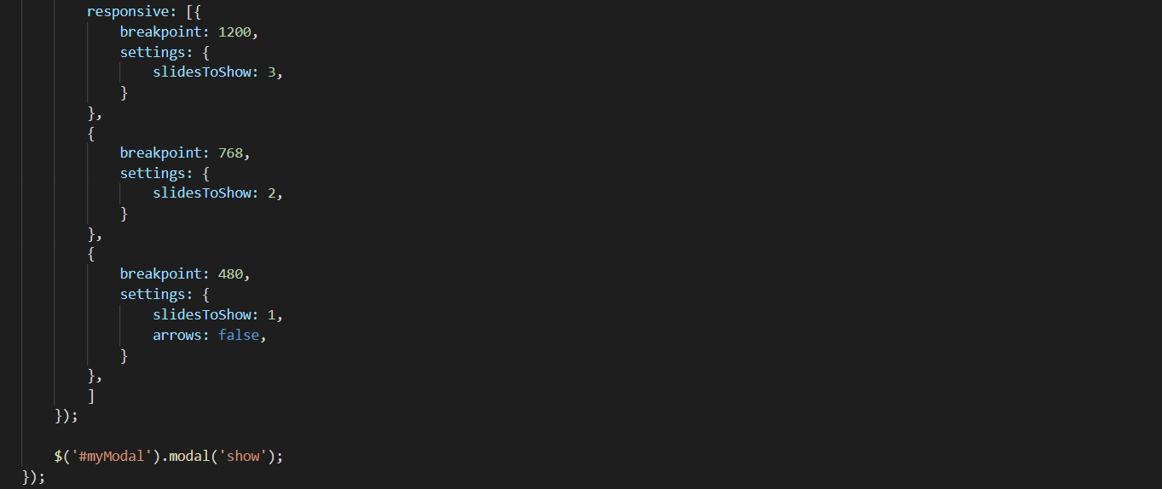

1. **Show number of product Javascript**
2. Description

This script is used to display the number of products by type, brand and feature

1. Screen shot

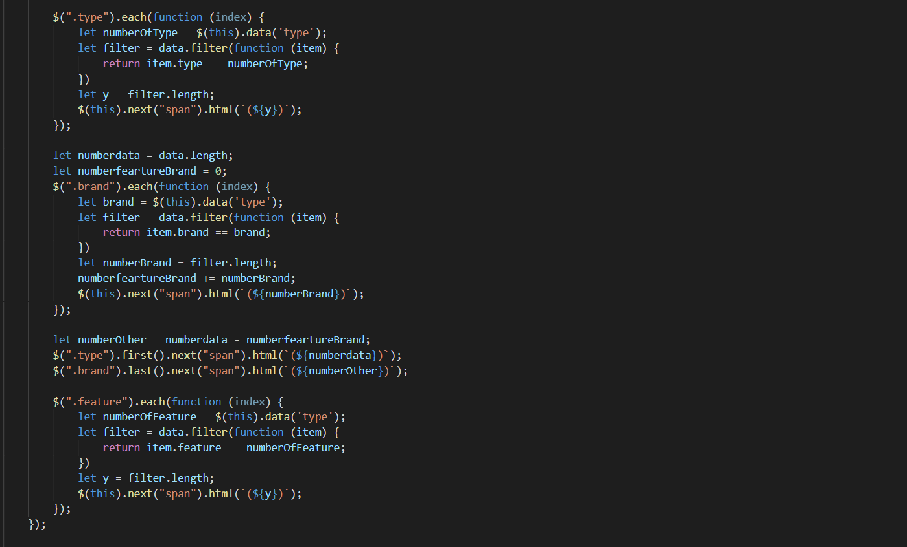

1. **Sign-in & Sign-up Javascript**
2. Description

This script used for member registration and login in the website.

1. Screen shot

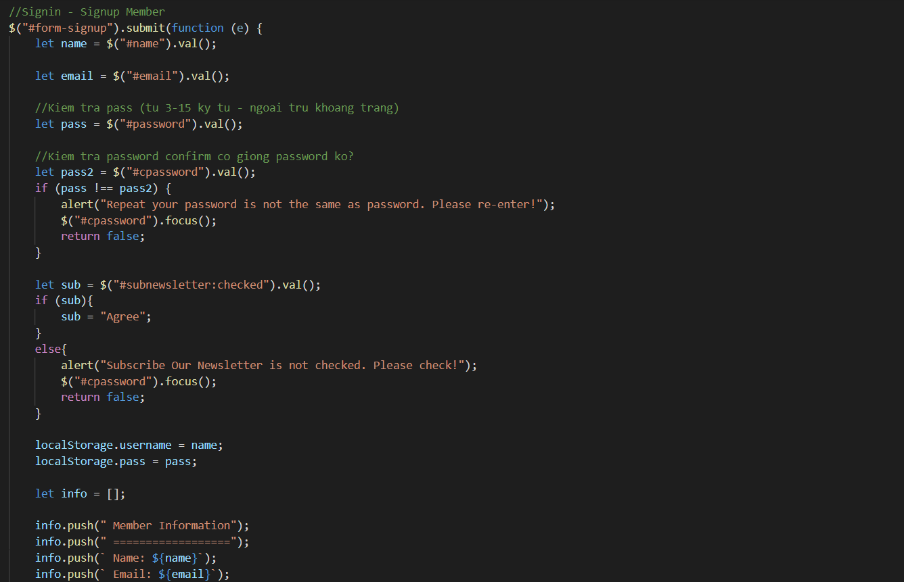

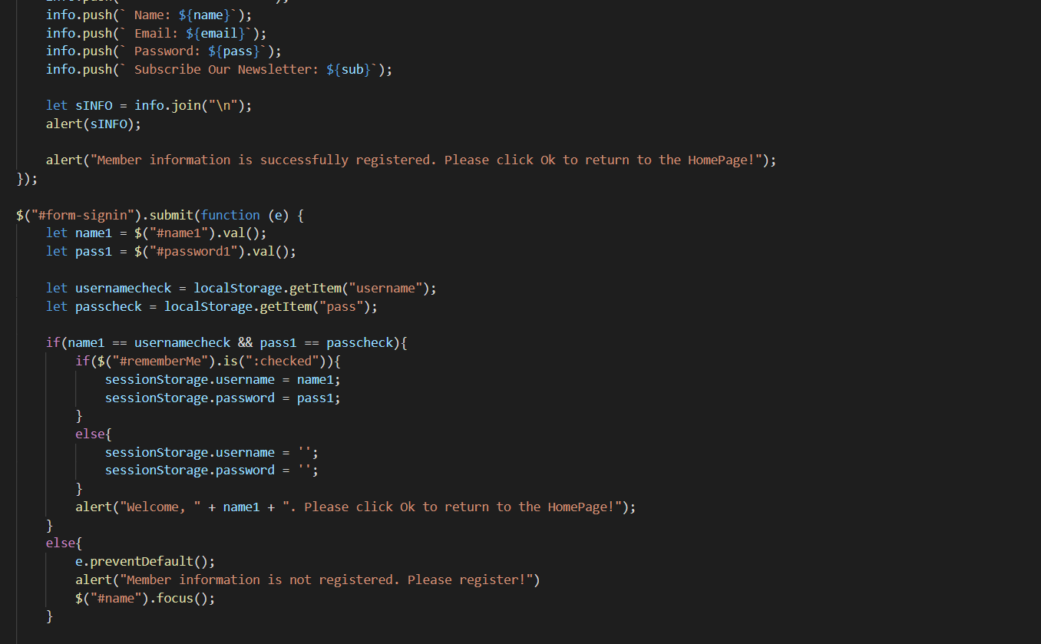

# TASK SHEET REVIEW 3

|  |  |  |  |  |  |  |  |
| --- | --- | --- | --- | --- | --- | --- | --- |
| **Project Ref. No.:**  **eP/Advertisement Portal Management**  **System/01** | | **Project Title:** | **Activity Plan Prepared By:** | **Date of Preparation of Activity Plan:** | | | |
| **Sr.**  **No.** | **Task** | **Actual**  **Start**  **Date** | **Actual Days** | **Team**  **Mate Names** | **Status** |
| 1 | Home Page | HARVEL  ELECTRIC | Dai | 18-July-21 | 1 | Dai | Completed |
| 2 | Product | 20-July-21 | 3 | Dai | Completed |
| 3 | Blog | 18-July-21 | 2 | Dung | Completed |
| 4 | About Us | 20-July-21 | 2 | Dung | Completed |
| 5 | Contact Us | 18-July-21 | 2 | Thanh | Completed |
| 6 | Service | 20-July-21 | 2 | Thanh | Completed |
| 7 | Sign In/ Sign Up | 22-July-21 | 1 | Thanh | Completed |
| 8 | Java Script | 23-July-21 | 2 | Dai | Completed |
| 9 | Responsive | 22-July-21 | 1 | Dung | Completed |

|  |  |
| --- | --- |
| **Date:** | |
| Signature of Instructor:  **Ms. Le Mong Thuy** | Signature of Team Leader:  **Nguyen Huu Dai** |